Manual scheduling:
What do you do when you do not have a scheduler in your cluster? You probably do not want to rely on the built in scheduler and instead want to schedule the pods yourself. So how exactly does a scheduler work in the backend?
Every pod has a field called node name that by default is not set. You don't typically specify this field when you create the pod manifest file. Kubernetes adds it automatically. The scheduler goes through all the pods and looks for those that do not have this property set. Those are the candidates for scheduling. It then identifies the right node for the pod by running the scheduling algorithm. Once identified, it schedules the pod on the node by setting the node name property to the name of the node by creating a binding object.
So, if there is no scheduler to monitor and schedule pods onto nodes, what happens? The pods continue to be in a pending state.
So, what can you do about it? You can manually assign pods to nodes yourself. Well, without a scheduler, the easiest way to schedule a pod is to simply set the node name field to the name of the node in your pod specification file while creating the pod. The pod then gets assigned to the specified node. You can only specify the node name at creation time.
apiVersion: V1
kind: Pod
metadata:
name: nginx
labels:
name: nginx
spec:
containers:
-name: nginx
image: nginx
ports:
-containerPort: 8080
nodeName: node02
What if the pod is already created and you want to assign the pod to a node? Kubernetes won't allow you to modify the node name property of a pod.
So, another way to assign a node to an existing pod is to create a binding object and send a Post request to the pods binding API, thus mimicking what the actual scheduler does in the binding object. You specify a target node with the name of the node, then send a Post request to the pods binding API with the data set to the binding object in a JSON format. So, you must convert the YAML file into its equivalent JSON form.
apiVersion: V1
kind: Binding
metadata:
name: nginx
target:
apiVersion: V1
kind: Node
name: node02

$ curl --header … --data ‘{“apiVersion”:”v1”,…}’ http://%server/api/$PODNAME/binding

Labels and Selectors:
Labels and selectors are a standard method to group things together. Say you have a set of different species.
A user wants to be able to filter them based on different criteria, such as based on their class or kind, if they are domestic or wild, or say by their color and not just group. You want to be able to filter them based on a criterion, such as all green animals, or with multiple criteria, such as everything green that is also a bird.
Whatever that classification may be, you need the ability to group things together and filter them based on your needs. And the best way to do that is with labels. Labels are properties attached to each item.
So, you add properties to each item for their class. Kind and color selectors help you filter these items. For example, when you say class equals mammal, we get a list of mammals. And when you say color equals green, we get the green mammals.
We see labels and selectors used everywhere, such as the keywords you tag to YouTube videos or blogs that help users filter and find the right content. We see labels added to items in an online store that help you add different kinds of filters to view your products.
So how are labels and selectors used in Kubernetes?
We have created a lot of different types of objects in Kubernetes pods, services, replica sets, deployments, etc... For Kubernetes, all of these are different objects.
Over time, you may end up having hundreds or thousands of these objects in your cluster. Then you will need a way to filter and view different objects by different categories, such as to group objects by their type or view objects by application or by their functionality, whatever it may be.
You can group and select objects using labels and selectors for each object. Attach labels as per your needs like app, function, etc. Then, while selecting specify a condition to filter specific objects.
For example, app equals app1. So how exactly do you specify labels in Kubernetes? In a Pod definition file under metadata, create a section called labels. Under that, add the labels in a key value format like this.
$ kubectl get pods --selector app=App1
Now this is one use case of labels and selectors.
Kubernetes objects use labels and selectors internally to connect different objects together. For example, to create a replica set consisting of three different parts. We first label the pod definition and use selector in a replica set to group the pods in a replica set definition file. You will see labels defined in two places.
Note that this is an area where beginners tend to make a mistake. The labels defined under the templates section are the labels configured on the pods. The labels you see at the top are the labels of the replica set itself. We're not really concerned about the labels of the replica set for now, because we are trying to get the replica set to discover the pods. The labels on the replica set will be used. If you were to configure some other object to discover the replica set. In order to connect the replica set to the pods, we configure the selector field under the replica set specification to match the labels defined on the pod.
A single label will do if it matches correctly. However, if you feel there could be other pods parts with the same label, but with a different function. Then you could specify both the labels to ensure that the right parts are discovered by the replica set on creation. If the labels match, the replica set is created successfully.
It works the same for other objects like a service. When a service is created, it uses the selector defined in the service definition file to match the labels set on the pods in the replica set definition file.
Finally, let's look at annotations. While labels and selectors are used to group and select objects, annotations are used to record other details for informatory purpose.
For example, tool details like name version, build information, etc. or contact details, phone numbers, email IDs, etc. that may be used for some kind of integration purpose. Well, that's it for this lecture on labels and selectors and annotations.
apiVersion: V1
kind: Service
metadata:
name: my-service
spec:
selector:
app: App1
ports:
-protocol: TCP
port: 80
targetPort: 9376

apiVersion: apps/V1
kind: ReplicaSet
metadata:
name: simple-webapp
labels:
app: App1
function: front-end
annotations:
buildversion: 1.34
spec:
replicas: 3
selector:
matchLabels:
app: App1
template:
metadata:
labels:
app: App1
function: front-end
spec:
containers:
-name: simple-webapp
Image: simple-webapp

Taints and Tolerations:
We will discuss about the pod to node relationship and how you can restrict what pods are placed on what nodes.
Taints and tolerations have nothing to do with security or intrusion on the cluster. Taints and tolerations are used to set restrictions on what pods can be scheduled on a node.
Let us start with a simple cluster with three worker nodes. The nodes are named one, two, and three. We also have a set of pods that are to be deployed on these nodes.
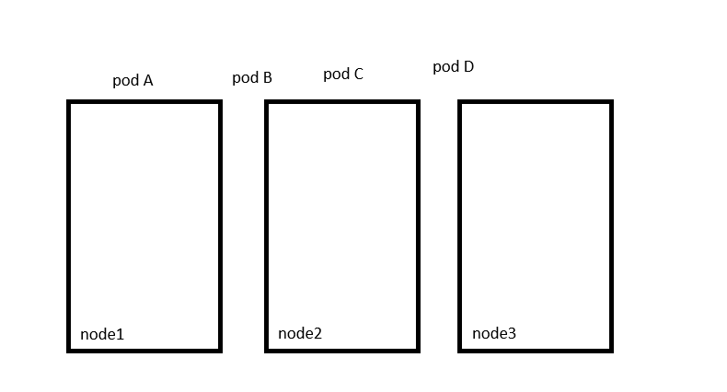
When the pods are created, Kubernetes Scheduler tries to place these pods on the worker nodes. As of now, there are no restrictions or limitations, and as such, the scheduler places the pods across all the nodes to balance them out equally.
Now let us assume that we have dedicated resources on node one for a particular use case or application. So, we would like only those parts that belong to this application to be placed on node one. First, we prevent all pods from being placed on the node by placing a taint on the node. Let's call it blue. By default, pods have no tolerations, which means unless specified otherwise, none of the pods can tolerate any taint. So, in this case, none of the pods can be placed on node one, as none of them can tolerate the taint blue.
This solves half of our requirement.
No unwanted pods are going to be placed on this node. The other half is to enable certain parts to be placed on this node. For this we must specify which pods are tolerant to this particular taint. In our case, we would like to allow only pod D to be placed on this node. So, we add a toleration to pod D. Pod D is now tolerant to blue. So, when the scheduler tries to place this pod on node one, it goes through node one can now only accept
pods that can tolerate the taint blue. So, with all the taints and tolerations in place, this is how the pods would be scheduled. The scheduler tries to place pod A on node one, but due to the time it is thrown off and it goes to node two, the scheduler then tries to place pod B on node one, but again due to the taint, it is thrown off and is placed on node three, which happens to be the next node. The scheduler then tries to place pod C to the node one. It is thrown off again and ends up on node two. And finally, the scheduler tries to place pod D on node one. Since the pod is tolerant to node one, it goes through.
So, remember things are set on nodes and tolerations are set on pods. How do you do this? Use the kube control taint nodes command to taint a node.
$ kubectl taint nodes node-name key=value:taint-effect
Specify the name of the node to taint followed by the taint itself, which is a key value pair. For example, if you would like to dedicate the node to pods in application blue, then the key value pair would be app blue. The taint effect defines what would happen to the pods if they do not tolerate the taint.
There are three taint effects no schedule, which means the pods will not be scheduled on the node, which is what we have been discussing. Prefer no schedule, which means the system will try to avoid placing a pod on the node, but that is not guaranteed. And third is no execute, which means that new pods will not be scheduled on the node and existing pods on the node, if any will be evicted if they do not tolerate the taint.
These parts may have been scheduled on the node before the taint was applied to the node. An example command would be to taint node, node1 with the key value pair app equals blue and an effect of no schedule tolerations are added to pods to add a toleration to a pod.
$ kubectl taint nodes node1 app=myapp:NoSchedule
First, pull up the pod definition file in the spec section of the pod definition file. Add a section called Tolerations. Move the same values used while creating the taint under this section.
apiVersion: V1
kind: Pod
metadata:
name: myapp-pod
spec:
containers:
-name: nginx
Image: nginx
Tolerations:
-key: “app”
operator: “Equal”
value: “blue”
effect: “NoSchedule”
The key is app operator is equal, value is blue and the effect is no schedule. And remember all of these values need to be encoded in double quotes.
When the pods are now created or updated with the new tolerations, they are either not scheduled on nodes or evicted from the existing nodes depending on the effect set.
Let us try to understand the no execute change effect in a bit more depth. In this example we have three nodes running some workload. We do not have any taints or tolerations at this point, so they are scheduled this way. We then decided to dedicate node one for a special application, and as such, we taint the node with the application name and add a toleration to the pod that belongs to the application, which happens to be pod D in this case. While tending the node, we set the taint effect to no execute, and as such, once the taint on the node takes effect, it evicts pod C from the node, which simply means that the pod is killed. The pod D continues to run on the node as it has a toleration to the tank blew.
Now, going back to our original scenario where we have taints and tolerations configured, remember taints and tolerations are only meant to restrict nodes from accepting certain paths. In this case, node1 can only accept pod D, but it does not guarantee that pod D will always be placed on node one, since there are no chains or restrictions applied on the other two nodes. Pod D may very well be placed on any of the other two nodes, so remember taints and Tolerations does not tell the pod to go to a particular node. Instead, it tells the node to only accept pods with certain tolerations.
So far, we have only been referring to the worker nodes, but we also have master nodes in the cluster, which is technically just another node that has all the capabilities of hosting a pod. Plus, it runs all the management software.
Now, I'm not sure if you noticed the scheduler does not schedule any pods on the master node. Why is that? When the Kubernetes cluster is first set up, a tent is set on the master node automatically. That prevents any pods from being scheduled on this node. You can see this as well as modify this behavior if required. However, a best practice is to not deploy application workloads on a master server.
$ kubectl describe node kubemaster | grep Taint
For delete the taint:
$ kubectl taint node controlplane node-role.kubernetes.io/master:NoSchedule -
Dash (-) is end of line is for untainted

Node Selectors:
You have a three-node cluster of which two are smaller nodes with lower hardware resources, and one of them is a larger node configured with higher resources. You have different kinds of workloads running in your cluster. You would like to dedicate the data processing workloads that require higher horsepower to the larger node, as that is the only node that will not run out of resources in case the job demands extra resources. However, in the current default setup, any pods can go to any nodes. So, in this case, pod C may very well end up on nodes 2 or 3, which is not desired. To solve this, we can set a limitation on the pods so that they only run on particular nodes.
There are two ways to do this:
The first is using node selectors, which is the simple and easier method for this. We look at the pod definition file we created earlier. This file has a simple definition to create a pod with a data processing image. To limit this pod to run on the larger node, we add a new property called node selector to the spec section and specify the size as large.
But wait a minute, where did the size large come from? And how does Kubernetes know which is the large node?
The key value pair of size and large are in fact labels assigned to the nodes. The scheduler uses these labels to match and identify the right node to place the pods on. To use labels in a node selector like this, you must have first labeled your nodes prior to creating this pod.
To label a node, use the command Kube cube control label nodes, followed by the name of the node and the label in a key value pair format.
$ kubectl label nodes <node-name> <label-key>=<label-value>
In this case it would be cube control label nodes node one.
$ kubectl label nodes node1 size=large
Now that we have labeled the node, we can get back to creating the pod, this time with the node selector set to a size of large.
apiVersion: V1
kind: Pod
metadata:
name: myapp-pod
spec:
containers:
-name: data-processor
Image: data-processor
nodeSelector:
size: Large
When the pod is now created, it is placed on node one as desired. Node selector served our purpose, but it has limitations. We used a single label and selector to achieve our goal here.
But what if our requirement is much more complex?
For example, we would like to say something like place the pod on a large or medium node or something like place the pod on any nodes that are not small. You cannot achieve this using node selectors.
For this node affinity and anti-affinity features were introduced and we will look at that next.

Node Affinity:
The primary purpose of node affinity feature is to ensure that pods are hosted on particular nodes.
The node affinity feature provides us with advanced capabilities to limit pod placement on specific nodes. With great power comes great complexity.
Therefore, the simple node selector specification will now resemble this with node affinity. Both do the same thing and place the pod on the large node.
Let us look at it a bit closer.
Under spec you have affinity and then node affinity under that. And then you have a property that looks like a sentence called required during scheduling, Ignored during execution.
No description needed for that. And then you have the node selector terms. That is an array. And that is where you will specify the key and value pairs. The key value pairs are in the form, key operator, and value where the operator is in the in operator ensures that the pod will be placed on a node whose label size has any value in the list of values specified here. In this case, it is just one called large. If you think your pod could be placed on a large or a medium node, you could simply add the value to the list of values like this. You could use the not in operator to say something like size, not in small, where node affinity will match the nodes with a size not set to small. We know that we have only set the label size to large and medium nodes, Notes. The smaller notes don't even have the label set, so we don't really have to even check the value of the label, as long as we are sure we don't set a label size to the smaller notes.
Using the exists operator will give us the same result.
The operator will simply check if the label size exists on the nodes, and you don't need the values section for that, as it does not compare the values.
There are a number of other operators as well. Check the documentation for specific details.
Now we understand all of this and we're comfortable with creating a pod with specific affinity rules. When the pods are created, these rules are considered and the pods are placed onto the right nodes.
But what if node affinity could not match a node with a given expression? In this case, what if there are no nodes with the label called size? Say we had the labels and the pods are scheduled. What if someone changes the label on the node at a future point in time. Will the pod continue to stay on the node? All of this is answered by the long sentence like property under node affinity, which happens to be the type of node affinity. The type of node affinity defines the behavior of the scheduler with respect to node affinity, and the stages in the lifecycle of the pod.
There are currently two types of node affinity available required during scheduling, ignored during execution, and preferred during scheduling, ignored during execution, and there are additional types of node affinity planned as of this recording. Required during scheduling. Required during execution.
There are two states in the lifecycle of a pod when considering node affinity during scheduling and during execution. During scheduling is the state where a pod does not exist and is created for the first time.
We have no doubt that when a pod is first created, the affinity rules specified are considered to place the pods on the right nodes. Now, what if the nodes with matching labels are not available? For example, we forgot to label the node as large.
That is where the type of node affinity used comes into play.
If you select the required type, which is the first one, the scheduler will mandate that the pod be placed on a node with the given affinity rules. If it cannot find one, the pod will not be scheduled. This type will be used in cases where the placement of the pod is crucial. If a matching node does not exist, the pod will not be scheduled.
But let's say the pod placement is less important than running the workload itself. In that case, you could set it to preferred. And in cases where a matching node is not found, the scheduler will simply ignore node affinity rules and place the pod on any available node. This is a way of telling the scheduler, hey, try your best to place the pod on matching node, but if you really cannot find one, just place it anywhere.
The second part of the property or the other state is during execution.
During execution is the state where a pod has been running, and a change is made in the environment that affects node affinity, such as a change in the label of a node.
For example, say an administrator removed the label we set earlier called size equals large from the node. Now, what would happen to the pods that are running on the node? As you can see, the two types of node affinity available today has this value set to ignored, which means pods will continue to run and any changes in node affinity will not impact them once they are scheduled.

Resource Limits:
Let us start by looking at a three node Kubernetes cluster. Each node has a set of CPU and memory resources available. Now every pod requires a set of resources to run. In this case, for example, this pod requires two CPUs and one memory unit. Now, whenever a pod is placed on a node, it consumes the resources available on that node. Now, as we have discussed before, it is the Kubernetes Scheduler that decides which node a pod goes to. The scheduler takes into consideration the amount of resources required by a pod and those available on the nodes, and identifies the best node to place a pod on. In this case, the scheduler schedules a new pod on node two because there are sufficient resources available on that node.
If nodes have no sufficient resources available. The scheduler avoids placing the pod on those nodes, and instead places the pod on one where sufficient resource is available, and if there are no sufficient resources available on any of the nodes, then the scheduler holds back, scheduling the pod and you will see the pod in a pending state. And if you look at the events using the cube control describe pod command, you will see there is an insufficient CPU.
Now let us now focus on the resource requirements for each pod. So, what are these blocks and what are their values. Now you can specify the amount of CPU and memory required for Pod when creating one. For example, it could be one CPU and one GB of memory and this is known as the resource request for a container. So, the minimum amount of CPU or memory requested by the container. So, when the scheduler tries to place the pod on a node, it uses these numbers to identify a node which has sufficient amount of resources available. So, to do this in the sample pod definition file, all you need to do is add a section called resources under which add requests and specify the new values for memory and CPU usage.
apiVersion: V1
kind: Pod
metadata:
name: simple-webapp-color
labels:
name: simple-webapp-color
spec:
containers:
-name: simple-webapp-color
Image: simple-webapp-color
ports:
-containerPort: 8080
resources:
requests:
memory: “4Gi”
cpu: 2
In this case, I set it to four gigabyte of memory and two counts of CPU. So, when the scheduler gets a request to place this pod, it looks for a node that has this amount of resources available. And when the pod gets placed on a node, the pod gets a guaranteed amount of resources available for it.
So, what does one count of CPU really mean? Now you can specify any value as low as 0.1. So, 0.1 CPU can also be expressed as 100 M, where M stands for milli, and you can go as low as one M, but not lower than that.
Now one count of CPU is equivalent to one Vcpu so that's one vcpu in AWS.
CPU | 1 AWS vCPU
CPU | 1 GCP Core
CPU | 1 Azure Core
1 | 1 Hyperthread

So, if you're looking at the AWS cloud, or it could be referred to as one core in GCP or Azure or one Hyperthread on other systems, and you could request a higher number of CPUs for the container provided your nodes are sufficiently funded. In this example, I have set it to five.
Now, similarly with memory, you could specify 256 mebibyte using the mi suffix, or specify the same value in memory like this. That's the full number, the whole number, and or specify the same value in memory like this as m.
MEM | 268435456 => The full number
256 mi | 268 m

Use the suffix g for uh gigabyte. So, note the difference between g and g. So, g is gigabyte and it refers to 1000MB, whereas g refers to GB byte. And that that would be equivalent to 1024MB. So, the same applies to megabyte and maybe byte in kilobyte and kibibyte.
Now let's look at a container running on a node, and by default, a container has no limit to the resources it can consume on a node. So, say a container that's part of a pod starts with one CPU on a node. It can go up and consume as much resources as it requires. And that suffocates the native processes on the node or other containers of resources. However, you can set a limit for the resource usage on these pods. For example, if you set a limit of one vcpu to the containers, a container will be limited to consume only one vcpu from that node. So, the same goes with memory.
For example, you can set a limit of 512 megabyte on containers. Now you can specify the limits under the limits section.
apiVersion: V1
kind: Pod
metadata:
name: simple-webapp-color
labels:
name: simple-webapp-color
spec:
containers:
-name: simple-webapp-color
Image: simple-webapp-color
ports:
-containerPort: 8080
resources:
requests:
memory: “4Gi”
cpu: 2
limits:
memory: “2Gi”
cpu: 2
Under the resources section in your Pod definition file. So here specify the new limits for memory and CPU.
Now when the pod is created, Kubernetes sets new limits for the container. And remember that the limits and requests are set for each container within a pod. So, if there are multiple containers, then each container can have a request or limit set for its own. So, what happens when a pod tries to exceed resources beyond its specified limit? In case of the CPU, the system throttles the CPU so that it does not go beyond the specified limit. A container cannot use more CPU resources than its limit.
However, this is not the case with memory. A container can use more memory resources than its limit, so if a pod tries to consume more memory than its limit constantly. The pod will be terminated and you will see that the pod terminated with an error in the logs or in the output of the describe command. When you run it, so that's what is Om refers to out of memory kill.
So now that we have learned what resource requests are and what limits are and how they function, and what happens when a particular container or pod hits the limits of that were defined, let's see what the default configuration is, right? So, by default Kubernetes does not have a CPU or memory request or limit set. So, this means that any pod can consume as much resources as required on any node, and suffocate other pods or processes that are running on the node of resources. this is very, very important to note.
Let's just look at how CPU requests and limits work. Let's say there are two pods competing for CPU resources on the cluster. And when I say pod, I mean a container within a pod. without a resource or a limit set, one pod can consume all the CPU resources on the node and prevent the second part of required resources. this is not ideal.
Now let's look at another case where we have no request specified. But we have limits specified. In this case, Kubernetes automatically sets requests to the same as limits. For example, requests and limits are assumed to be three in this case, and each pod is guaranteed three vCPUs and no more than that, as limits are also set to the same.
The next one is where requests and limits are set. In this case, each pod gets a guaranteed number of CPU requests, which is one vcpu and can go up to the limits that is defined, which is three vcpu, but not more. this might look to be the most ideal scenario.
However, the issue is that if Pod one needs more CPU cycles for some reason and pod two isn't really consuming that many CPU cycles, then we don't want to limit pod one of CPU, right? we'd like to allow pod one to use the available CPU cycles, as long as pod two doesn't really need it.
If there are sufficient CPU cycles available on the system, then why not let the pods use them? we don't want to unnecessarily limit resources of CPU cycles. that is not really the ideal scenario. And that's where the last scenario comes in.
Setting requests but no limits in this case because requests are set each pod is guaranteed one vcpu. However, because limits are not set when available, any pod can consume as many CPU cycles as available. But at any point in time, if pod two is requires additional CPU cycles or whatever it is. It has requested, then it will be guaranteed its requested CPU cycle. this is the most ideal setup.
Of course, there are cases where you absolutely may want to limit a pod of resources, and in that case, you may set limits.
For example, a good use case for setting limits is our labs themselves, where all the labs you've been to, you have been going through and accessing as part of this course, and they are hosted as containers on a cluster.
And since it's made accessible to public and users can run any kind of workload that they want, we set limits to prevent the user from misusing the infrastructure to, let's say, perform Bitcoin mining or other resource consuming activities.
So that works for us in that case. But in your case, if you don't want to restrict your application to consume additional CPU, if needed, then you could consider not setting limits. But remember, if you were to do that, you need to make sure that all the pods have some request set, because that's the only way a pod will have resources guaranteed when there are no limits set for other pods.
So, if there is any pod that has no request set and there are no limits set for all the other pods, then it's possible that any pod could consume all the memory, all the CPU that's available on the node, and starve the pod that has no request defined. So just make sure that you have set requests for all the nodes.
So, a couple of things to note. The requests and limits may be different for each pod, but for the sake of simplicity we are assuming that it's the same for both pods in these examples that I'm sharing here. But you can have absolutely different requests or limit set for containers for each container within each pod.
So also note that these recommendations are just for CPU. if you look at the memory let’s, say there are two. In the first case there are two pods competing for memory resources on the cluster. And without a resource or limit set, one pod can consume all the memory resources on the node and prevent the second pod of required resources. this is not ideal.
Now let's look at the case where we have no requests specified. But we do have limits specified. And in this case Kubernetes automatically sets requests to the same as limits. for example, requests and limits are assumed to be three gigabytes in this case. And each pod is guaranteed three gigabytes and no more as limits is also the same.
The next one is where requests and limits are set. each pod gets a guaranteed amount of memory, which is one gigabyte and can go up to the limits defined, which is three gigabytes but not more.
And the last one is setting requests, but no limits. because requests are set, each pod is guaranteed one gigabyte. However, because limits are not set when available, any pod can consume as much memory as available, and if pod two requests more memory to free up pod one, the only option available is to kill it now, because unlike CPU, we cannot throttle memory once memory is assigned to a pod. The only way to kind of retrieve it is to kill the pod and free up all the memory that are used by it.
By default, Kubernetes does not have resource requests or limits configured for pods. But then how do we ensure that every pod created has some defaults? Now this is possible with limit ranges. limit ranges can help you define default values to be set for containers in pods that are created without a request or limit specified in the Pod definition files.
This is applicable at the namespace level. remember that and this is an object.
apiVersion: V1
kind: LimitRange
metadata:
name: cpu-resource-constraint
spec:
limits:
-default:
cpu: 500m
defaultRequest:
cpu: 500m
max:
cpu: “1”
min:
cpu: 100m
type: container

apiVersion: V1
kind: LimitRange
metadata:
name: cpu-resource-constraint
spec:
limits:
-default:
memory: 1Gi
defaultRequest:
memory: 1Gi
max:
memory: 1Gi
min:
memory: 500Mi
type: container

So, if you create or change a limit range it does not affect existing pods. It will only affect newer pods that are created after the limit range is created or updated.
And finally, is there any way to restrict the total amount of resources that can be consumed by applications deployed in a Kubernetes cluster. For example, if we had to say that all the pods together shouldn't consume more than this much of CPU or memory.
What we could do is create quotas at a namespace level. So, a resource quota is a namespace level object that can be created to set hard limits for requests and limits.
apiVersion: V1
kind: ResourceQuota
metadata:
name: my-resource-quota
spec:
hard:
requests.cpu: 4
requests.memory: 4Gi
limits.cpu: 10
limits.memory: 10Gi

Daemon Sets:
So, far we have deployed various pods on different nodes in our cluster with the help of replica sets and deployments. We made sure multiple copies of our applications are made available across various different worker nodes.
Daemonsets are like replica sets, as in, it helps you deploy multiple instances of pods, but it runs one copy of your pod on each node in your cluster. Whenever a new node is added to the cluster, a replica of the pod is automatically added to that node, and when a node is removed, the pod is automatically removed. The daemonset ensures that one copy of the pod is always present in all nodes in the cluster.
What are some use cases of Daemonsets? You would like to deploy a monitoring agent or log collector on each of your nodes in the cluster, you can monitor your cluster better. A daemonset is perfect for that, as it can deploy your monitoring agent in the form of a pod in all the nodes in your cluster. Then you don't have to worry about adding or removing monitoring agents from these nodes when there are changes in your cluster, as the Daemonset will take care of that for you.
Earlier, while discussing the Kubernetes architecture, we learned that one of the worker node components that is required on every node in the cluster is a kube proxy. That is one good use case of Daemonsets. The kube proxy component can be deployed as a daemonset in the cluster.
Another use case is for networking. Networking solutions like calico requires an agent to be deployed on each node in the cluster.
Creating a demon set is similar to the replica set creation process. It has nested pod specification under the templates section and selectors to link the demon set to the pods.
A daemon set definition file has a similar structure.
apiVersion: apps/V1
kind: ReplicaSet
metadata:
name: monitoring-daemon
spec:
selector:
matchLabels:
app: monitoring-agent
template:
metadata:
labels:
app: monitoring-agent
spec:
containers:
-name: monitoring-agent
Image: monitoring-agent

apiVersion: apps/V1
kind: DaemonSet
metadata:
name: monitoring-daemon
spec:
selector:
matchLabels:
app: monitoring-agent
template:
metadata:
labels:
app: monitoring-agent
spec:
containers:
-name: monitoring-agent
Image: monitoring-agent

Kind is daemon set instead of replica set. It's almost exactly like the replica set definition, except that the kind is a daemon set. Ensure the labels in the selector matches the ones in the pod template.
Create daemon:
$ kubectl create -f daemonset-definition.yaml
List Create daemon:
$ kubectl get daemonsets
More details:
$ kubectl describe daemonsets monitoring-daemon
How does a demon set work? How does it schedule pods on each node? And how does it ensure that every node has a pod? If you were asked to schedule a pod on each node in the cluster, how would you do it?
In one of the previous lectures in this section, we discussed that we could set the node name property on the pod to bypass the scheduler and get the pod placed on a node directly. So that's one approach. On each pod, set the node name property in its specification before it is created, and when they are created, they automatically land on the respective nodes. So that's how it used to be until Kubernetes version 1.12.
From version 1.1 onwards, the daemon set uses the default scheduler and node affinity rules that we learned in one of the previous lectures to schedule pods on nodes.
Well, that's it for this lecture.
Head over to the Practice test and practice working with Daemon Sets.

Static Pods:
The Kubelet relies on the kube API server for instructions on what pods to load on its node, which was based on a decision made by the kube scheduler which was stored in the etcd data store.
What if there was no kube API server and kube scheduler, and no controllers and no etcd cluster? What if there was no master at all? What if there were no other nodes? What if you're all alone in the sea by yourself? Not part of any cluster. Is there anything that the Kubelet can do as the captain of the ship? Can it operate as an independent node? If so, who would provide the instructions required to create those pods?
The Kubelet can manage a node independently on the ship host. We have the Kubelet installed and of course we have container D as well to run containers. There is no Kubernetes cluster, so there are no kube API server or anything like that. The one thing that the Kubelet knows to do is create pods, but we don't have an API server here to provide pod details. By now we know that to create a pod, you need the details of the pod in a pod definition file. But how do you provide the pod definition file to the kubelet without a kube API server? You can configure the Kubelet to read the Pod definition files from a directory on the server, designated to store information about pods. Place the pod definition files in this directory. The Kubelet periodically checks this directory for files, reads these files, and creates pods on the host.
Not only does it create the pod, it can ensure that the pod stays alive if the application crashes, the kubelet attempts to restart it. If you make a change to any of the file within this directory, the Kubelet recreates the pod for those changes to take effect. If you remove a file from this directory, the pod is deleted automatically. So, these pods that are created by Kubelet on its own, without the intervention from the API server or the rest of the Kubernetes cluster components are known as static pods.
Remember, you can only create pods this way. You cannot create replica sets or deployments or services by placing a definition file in the designated directory. They're all concepts, part of the whole Kubernetes architecture that requires other cluster plane components like the replication and deployment controllers, etc. the Kubelet works at a pod level and can only understand pods, which is why it is able to create static pods this way.
What is that designated folder and how do you configure it?
It could be any directory on the host, and the location of that directory is passed in to the kubelet as an option while running the service. The option is named Pod Manifest Path and here it is set to etc Kubernetes Manifest folder. There is also another way to configure this. Instead of specifying the option directly in the Kubelet service file, you could provide a path to another config file using the config option and define the directory path as static pod path in that file.
kubelet.service
ExecStart=…
…
--pod-manifest-path=/etc/Kubernetes/manifests or kubeconfig.yaml
Kubeconfig.yaml
Staticpodpath=/etc/Kubernetes/manifests
Clusters set up by the Kube admin tool uses this approach. If you're inspecting an existing cluster, you should inspect this option of the Kubelet to identify the path to the directory.
You will then know where to place the definition file for your static pods, so keep this in mind when you go through the labs.
You should know to view and configure this option, irrespective of the method used to set up the cluster. First check the option pod manifest path in the Kubelet service file. If it's not there, then look for the config option and identify the file used as the config file and then within the config file, look for the static pod path option. Either of this should give you the right path.
Once the static pods are created, you can view them by running the docker PS command. So why not the kube control command as we have been doing so far?
Remember, we don't have the rest of the Kubernetes cluster yet, so the kube control utility works with the kube API server since we don't have an API server now. No kube control utility, which is why we're using the docker command.
So then how does it work when the node is part of a cluster? When there is an API server requesting the Kubelet to create pods, can the Kubelet create both kinds of pods at the same time? Well, the way the Kubelet works is it can take in requests for creating pods from different inputs. The first is through the Pod definition files from the static parts folder as we just saw. The second is through an http API endpoint, and that is how the kube API server provides input to Kubelet. The Kubelet can create both kinds of pods, the static pods, and the ones from the API server at the same time.
Is the API server aware of the static pods created by the Kubelet?
Yes, it is. If you run the kube control get pods command on the master node, the static pods will be listed as any other pod.
How is that happening? When the Kubelet creates a static pod, if it is a part of a cluster, it also creates a mirror object in the kube API server. What you see from the kube API server is just a read only mirror of the pod. You can view details about the pod, but you cannot edit or delete it like the usual pods. You can only delete them by modifying the files from the node's manifest folder. Note that the name of the pod is automatically Appended with the node name, in this case node01.
So then why would you want to use static paths?
Since static pods are not dependent on the Kubernetes control plane, you can use static pods to deploy the control plane components itself as pods on a node. Well, start by installing Kubelet on all the master nodes, then create pod definition files that uses Docker images of the various control plane components such as the API, server, controller, etcd, etc.
Place the definition files in the designated manifest folder, and the Kubelet takes care of deploying the control plane components themselves as pods on the cluster. This way you don't have to download the binaries, configure services, or worry about the services crashing if any of these services were to crash. Since it's a static pod, it will automatically be restarted by the kubelet. Neat and simple.
That's how the Kube admin tool sets up a Kubernetes cluster, which is why when you list the pods in the kube system namespace, you see the control plane components as pods in a cluster setup by the Kube admin tool.
$ kubectl get pods -n kube-system
Difference between static pods and daemon sets. Daemon sets, as we saw earlier, are used to ensure one instance of an application is available on all nodes in the cluster. It is handled by a daemon set controller through the kube API server, whereas static pods are created directly by the Kubelet without any interference from the kube API server or rest of the Kubernetes control plane. Components.
Static pods can be used to deploy the Kubernetes control plane components itself.
Both static pods and pods created by daemon sets are ignored by the kube scheduler.
The kube scheduler has no effect on these pods.
Static Pods | Daemon Sets
Create bye the kubelet | Create by the kube API server (DeamonSet controller)
Deploy control plane components as static pods | Deploy monitoring agents, logging agents on nodes

$ kubectl get pod -A
If the name of every pod end with -controlplane is static or check with information (describe command).
ownerReferences:
-apiVersion: v1
controller: true
kind: Node
name: controlplane
Where is the path of static pod definition file?
cat /var/lib/kubelet/config.yaml => check value of: staticPodPath

Priority Classes:
We know that Kubernetes runs different applications as pods with different priorities. For example, the Kubernetes control plane components itself run as pods within the cluster. And we know that no matter what, those workloads need to always run. Similarly, we may have priority databases, critical applications running on the cluster as well as lower priority workloads like background jobs. Now, we need a way to make sure that higher priority workloads always get scheduled without being interrupted by lower priority workloads.
This is where priority classes come in. Priority classes help us define priorities for different workloads, so that higher priority workloads always get priority over lower priority ones. If a higher priority pod cannot be scheduled, the scheduler will try to terminate a lower priority workload to make that happen.
So, priority classes are non namespaced objects, meaning they are not created within a specific namespace. They are not attached to a specific namespace. So, once they're created, they're available to be configured on any pod in any namespace.
So how do you define priorities? We define priorities using a range of numbers. a priority can be defined as high as 1 billion (1000000000) and as low as -2 billion (-2147483648) or around that number.
A larger number indicates higher priority.
Now, the range I've just mentioned is for the applications and workloads deployed on the cluster. The positive 1 billion to -2 billion number represents the applications or workloads deployed as apps on the cluster.
But there is a separate range that's dedicated for internal system critical parts such as the Kubernetes control plane components itself. they always get the highest priority. and they have priorities up to 2 billion.
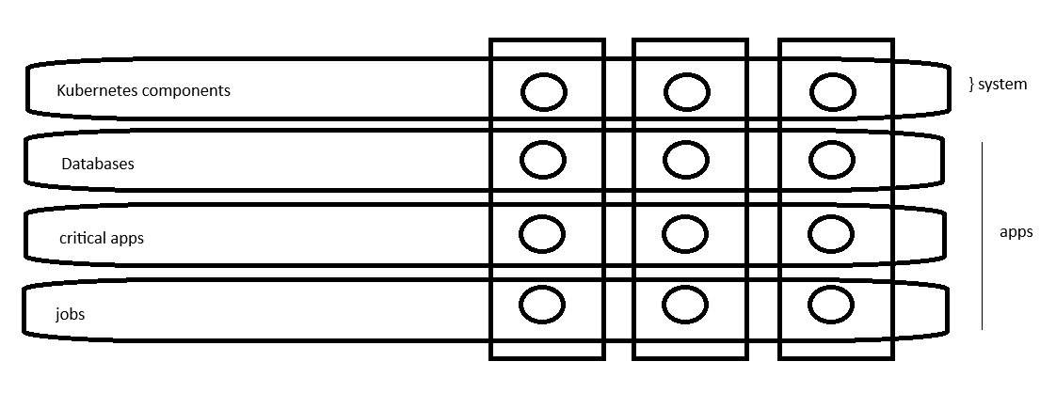
List existing priority classes run the kubectl get priority class command.
$ kubectl get priorityclass
Create a new priority class, we create an object with the API version set to scheduling v1 kind set to priority class metadata with a name. And then we define the value. this is the number that we just spoke about. And finally, we have the description. The description is an optional field.
apiVersion: scheduling.k8s.io/V1
kind: PriorityClass
metadata:
name: high-priority
value: 1000000000
description: “priority class for mission critical pods”
Once this is created, we associate this priority class to a pod by using the priority class name property inside the pod definition.
apiVersion: V1
kind: Pod
…
spec:
containers:
…
priorityClassName: high-priority
When that pod is created, it is assumed to have this priority that is assigned to the priority class.
Now, what if I don't specify a priority class name for a pod? By default, it is assumed to have a priority value of zero. However, if you'd like to modify that, you must create a new priority class and assign the global default property to true. this is an optional field, but it can be used to define the default priority of all the pods.
apiVersion: scheduling.k8s.io/V1
kind: PriorityClass
metadata:
name: high-priority
value: 1000000000
description: “priority class for mission critical pods”
globalDefault: true

If there are no priority class name explicitly defined in that pod's configuration file. Also note that it can only be defined in a single priority class, so the global default property can only be defined in a single priority class because you cannot have multiple default values, right? you cannot have more than one priority class with the global default property set to true.
Now let us look at the effect of pod priority. say there are two workloads with two priorities coming in to be scheduled a critical app with a higher priority of seven, and a jobs app with a lower priority of five. Now, since the critical app is of higher priority, it gets placed first. And if there are still resources available. what you see here are the available resources on the cluster or the consumption of the resources on the cluster. there are still some more resources left. the workload with the lower priority also gets placed. next after the higher priority pod gets placed.
Now let's say we have a higher priority job that comes in with a priority of six. And there are no more resources available on the cluster. What happens? Do we evict existing workload or does it wait? What does it do?
Now that behavior is defined by the preemption policy defined in the priority class assigned to the new workload.
apiVersion: scheduling.k8s.io/V1
kind: PriorityClass
metadata:
name: high-priority
value: 1000000000
description: “priority class for mission critical pods”
globalDefault: true
preemptionPolicy: PreemptLowerPriorit or never
If the preemption policy is not set, its default value is set to preempt a lower priority. This means that it would kill the existing lower priority job and take its place.
But if you do not want it to kill or evict the existing workload, and instead wait for the cluster resources to free up, then you must set this preemption policy to never. a preemption policy set to never makes the pods in that priority class non preempting, meaning that they cannot preempt other pods and it will wait to be scheduled in the scheduling queue. However, they will get a higher priority in scheduling over other lower priority pods that are also waiting to be scheduled. there's the priority still applies only when it is going to be scheduled. But will it kill the existing preempt, or will it evict the existing workload or not?
That is defined by the preemption policy.

Multiple Schedulers:
The default has an algorithm that distributes pods across nodes evenly, as well as takes into consideration various conditions. We specify through taints and tolerations and node affinity, etc.
But what if none of these satisfies your needs? Say you have a specific application that requires its components to be placed on nodes after performing some additional checks, so you decide to have your own scheduling algorithm to place pods on nodes so that you can add your own custom conditions and checks in.
Kubernetes is highly extensible. You can write your own Kubernetes Scheduler program, package it, and deploy it as the default scheduler, or as an additional scheduler in Kubernetes cluster. That way, all of the other applications can go through the default scheduler.
However, some specific applications that you may choose can use your own custom scheduler, so your Kubernetes cluster can have multiple schedulers at a time. When creating a pod or a deployment, you can instruct Kubernetes to have the pod scheduled by a specific scheduler.
When there are multiple schedulers, they must have different names so that we can identify them as separate schedulers. the default scheduler is named default scheduler. And this name is configured in a kube scheduler configuration file that looks like this.
apiVersion: kubescheduler.config.k8s.io/v1
kind: KubeSchedulerConfiguration
profiles:
-SchedulerName: default-scheduler
Now the default scheduler doesn't really need one because if you don't specify a name, it sets the name to default scheduler. But this is how it would look if you were to create one. And for the other schedulers, we could create a separate configuration file and set the scheduler name like this.
apiVersion: kubescheduler.config.k8s.io/v1
kind: KubeSchedulerConfiguration
profiles:
-SchedulerName: my-scheduler

apiVersion: kubescheduler.config.k8s.io/v1
kind: KubeSchedulerConfiguration
profiles:
-SchedulerName: my-scheduler-2
Deploying an additional scheduler: Now earlier we saw how to deploy the Kubernetes Kube scheduler. We download the kube scheduler binary and run it as a service with a set of options. Now, to deploy an additional scheduler, you may use the same kube scheduler binary or use one that you might have built for yourself, which is what you would do if you needed the scheduler to work differently.
In this case, we're going to use the same binary to deploy the scheduler, and this time we point the configuration to the custom configuration file that we created.
Kube-scheduler.service
ExecStart=/usr/local/bin/kube-scheduler \\
--config=/etc/Kubernetes/config/kube-scheduler.yaml

my-scheduler-2.service
ExecStart=/usr/local/bin/kube-scheduler \\
--config=/etc/Kubernetes/config/my-scheduler-2-config.yaml

my-scheduler.service
ExecStart=/usr/local/bin/kube-scheduler \\
--config=/etc/Kubernetes/config/my-scheduler-config.yaml

So, each scheduler uses a separate configuration file, and with each file having its own scheduler name. Note that there are other options to be passed in, such as the kube config file to authenticate into the Kubernetes API, but I'm just skipping that for now just to keep it super simple.
This is not how you would deploy a custom scheduler 99% of the time today, because with kube ADM deployment, all the control plane components run as a pod or a deployment within the Kubernetes cluster.
So, let's look at another way. let's look at how it works if you were to deploy the scheduler as a pod. we create a pod definition file and specify the Kube config property, which is the path to the scheduler conf file that has the authentication information to connect to the Kubernetes API server. We then pass in our custom kube scheduler configuration file as a config option to the scheduler.
apiVersion: v1
kind: Pod
metadata:
name: my-custom-scheduler
namespace: kube-system
spec:
container:
-command:
-kube-scheduler
- --address=127.0.0.1
- --kubeconfig=/etc/Kubernetes/scheduler.conf
- --config=/etc/Kubernetes/my-scheduler-config.yaml
image: k8s.gcr.io/kube-scheduler-adm64:v1.xx.x
name: kube-scheduler
Note that we have the scheduler name specified in the file, so that's how the name gets picked up by the scheduler.
apiVersion: Kubernetes.config.k8s.io/v1
kind: KubeSchedulerConfiguration
profiles:
-schedulerName: my-scheduler
leaderElection:
leaderElect: true
resourceNameSpace: kube-system
resourceName: lock-object-my-scheduler
Now another important option to look here is the leader elect option. And this goes into the scheduler configuration. The leader elect option is used when you have multiple copies of the scheduler running on different master nodes, as in a high availability setup where you have multiple master nodes with the scheduler process running on both of them. If multiple copies of the same scheduler are running on different nodes, only one can be active at a time, and that's where the leader elect option helps in choosing a leader who will lead the scheduling activities.
In case you do have multiple masters, just remember that you can pass in this additional parameter to set a log object name. And, this is to differentiate that the new custom scheduler from the default selection process.
Deploy the scheduler as a deployment: use the Kubernetes documentation pages.
See new custom scheduler is running:
$ kubectl get pods --namespace=kube-system
Now, once we have deployed that custom scheduler, the next step is to configure a pod or a deployment to use this scheduler. how do you use our custom scheduler? here we have a pod definition file. And what we need to do is add a new field called scheduler name and specify the name of the scheduler.
apiVersion: v1
kind: Pod
metadata:
name: nginx
spec:
containers:
-name: nginx
Image: nginx
schedulerName: my-custom-scheduler
This way when the pod is created, the right scheduler gets picked up and the scheduling process works. Now create the pod using the kubectl create command. If the scheduler was not configured correctly, then the pod will continue to remain in a pending state. And if everything is good, then the pod will be in a running state.
So, if the pod is in the pending state, then you can look at the logs under the pod describe command. If you've got a describe command and you'll mostly notice that the scheduler isn't configured correctly.
Now how do you know which scheduler picked it up, have multiple schedulers? How do you know which scheduler picked up scheduling a particular pod?
Now we can view this in the events using the kubectl get events command:
$ kubectl get events -o wide
You could also view the logs of the scheduler in case you run into issues.
$ kubectl logs my-custom-scheduler --namespace=kube-system
List of the service account:
$ kubectl get sa -n kube-system
Create configmap from specific config map:
$ kubectl create configmap my-scheduler-config --from-file=/root/my-scheduler-config.yaml -n kube-system
$ kubectl get configmap -n kube-system
Configuring Scheduler Profiles:
Let's first recap how the Kubernetes Scheduler works. Using this simple example of scheduling a pod to one of these four nodes that you can see here that are part of the Kubernetes cluster. So here we have our pod definition file. And there's our pod.
apiVersion: V1
kind: Pod
metadata:
name: simple-webapp-color
spec:
priorityClassName: high-priority
container: data-processor
- name: simple-webapp-color
image: simple-webapp-color
resources:
request:
memory: “1Gi”
cpu: 10
It is waiting to be scheduled on one of these four nodes. Now it has a resource requirement of ten CPU. So, it's only going to be scheduled on a node that has ten CPU remaining. And you can see the available CPU on all of these nodes that are listed here.
Now it is not alone. There are some other pods that are waiting to be scheduled as well. So, the first thing that happens is that when these pods are created, the pods end up in a scheduling queue. this is where the pods wait to be scheduled. at this stage, pods are sorted based on the priority defined on the pods.
In this case our pod has a high priority set. to set a priority you must first create a priority class that looks like this. And you should set it a name and set it a priority value.
apiVersion: scheduling.k8s.io/V1
kind: PriorityClass
metadata:
name: high-priority
value: 1000000
globalDefault: false
description: “The priority class should be used for XYZ service pods only”
In this case it's set to 1 million. that's really high priority. This is how pods with higher priority gets to the beginning of the queue to be scheduled first. And so that sorting happens in this scheduling phase. Then our pod enters the filter phase. This is where nodes that cannot run the pod are filtered out. in our case the first two nodes do not have sufficient resources. So do not have ten CPU remaining. they are filtered out.
The next phase is the scoring phase. this is where nodes are scored with different weights from the two remaining nodes. The scheduler associates a score to each node based on the free space it will have after reserving the CPU required for that part. in this case the first one has two left and the second will have six lefts. the second node gets a higher score. And so that's the node that gets picked up.
And finally in the binding phase this is where the pod is finally bound to a node with the highest score. Now all of these operations are achieved with certain plugins.
For example, while in the scheduling queue it's the priority sort plugin that sorts the pods in an order based on the priority configured on the pods. This is how pods with priority class gets higher priority over the other pods when scheduling.
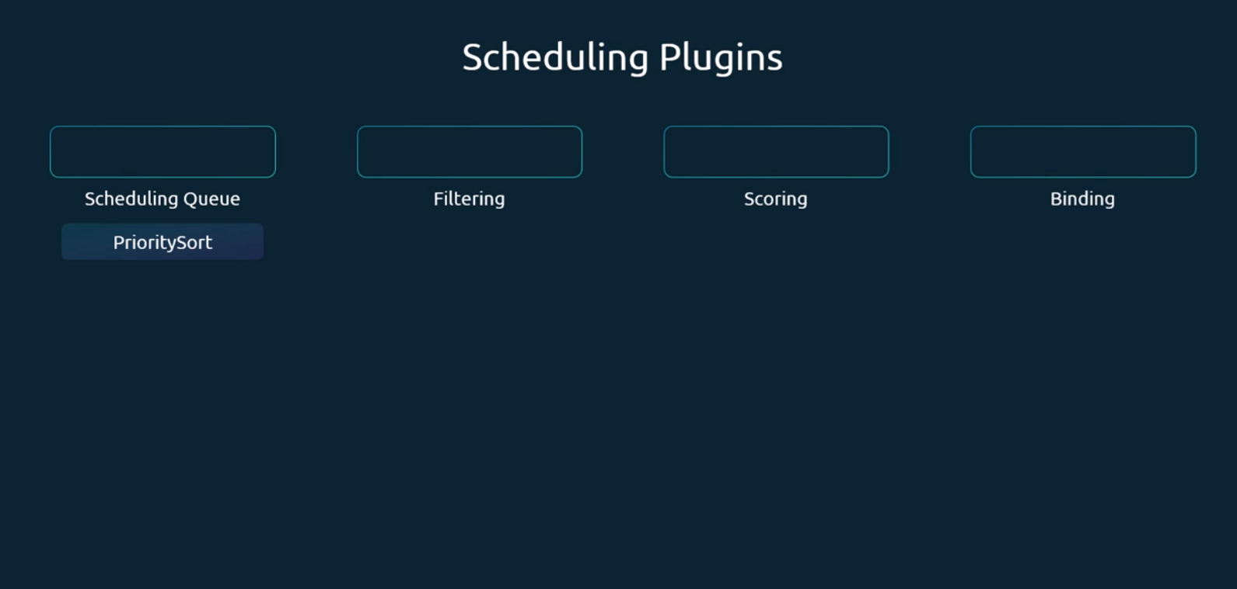
In the filtering stage, it's the Node Resources Fit plugin that identifies the nodes that has sufficient resources required by the pods, and filters out the nodes.
Now, some other plugin examples that come into this particular stage are the node name plugin that checks if a pod has a node name mentioned in the pod spec, and filters out all the nodes that does not match this name.
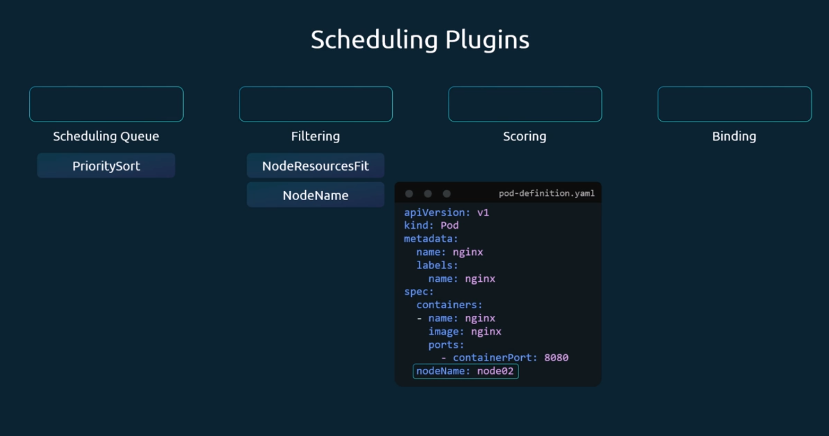
Another example is the node unschedulable plugin, and that filters out nodes that has the Unschedulable flag set to true, It's this particular plugin that makes sure that no pods are set on those nodes.
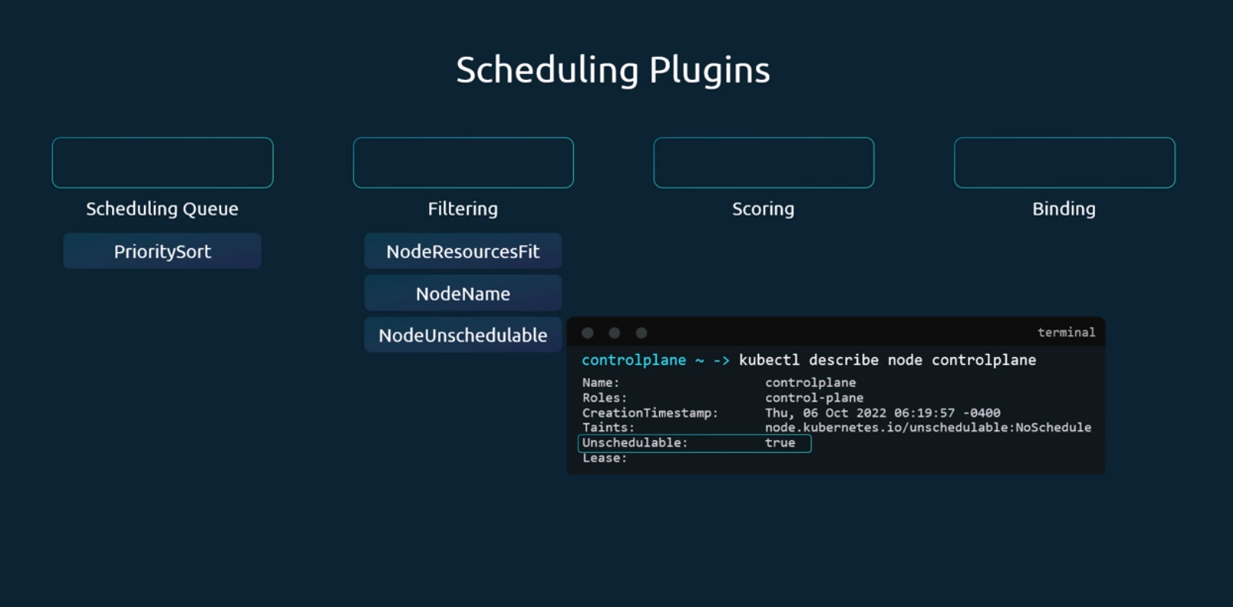
Now in the scoring phase again, the Node Resources Fit plugin associates a score to each node based on the resource available on it, and after the pod is allocated to it. So, as you can see, a single plugin can be associated in multiple different phases. Another example of a plugin in this stage would be the image locality plugin, that associates a high score to the nodes that already has the container image used by the pods among the different nodes.
Now note that at this phase, the plugins do not really reject the pod placement on a particular node. For example, in case of the image locality node, it ensures that pods are placed on a node that already has the image. But if there are no nodes available, it will anyway place the pod on a node that does not even have the image. So, it's just a scoring that happens at this stage.
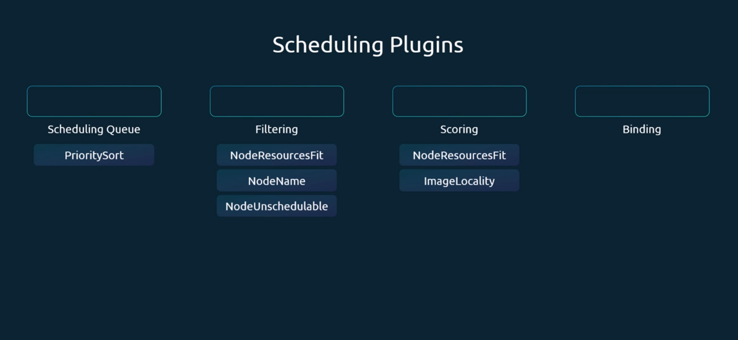
And finally, in the binding phase, you have the default binder plugin that provides the binding mechanism.
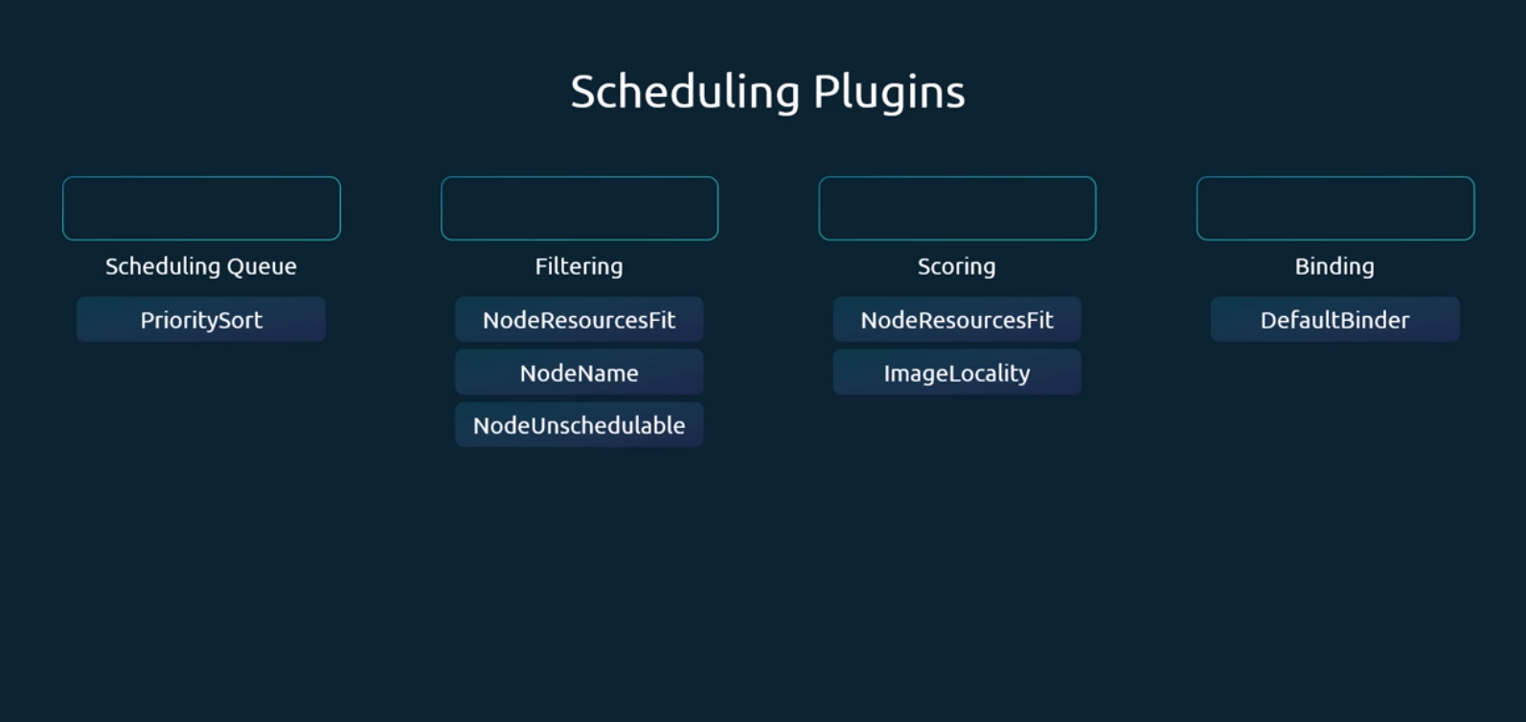
Now, the highly extensible nature of Kubernetes makes it possible for us to customize what plugins go where, and for us to write our own plugin and plug them in here. And that is achieved with the help of what is called as extension points. So, at each stage, there is an extension point to which a plugin can be plugged to. In the scheduling queue, we have a queue sort extension to which the Priority Sort plugin is plugged to, and then we have the filter extension, the score and the bind extension to which each of these plugins that we just talked about are plugged two. As a matter of fact, there's more. So, there are extensions before entering the filter phase called the Prefilter extension, and the and after the filter phase called post filter. And then there are Pre-score before the score extension point and reserve after the extension point, the score extension point. And then there is permit and pre bind before the bind and post bind after the binding phase. So, there are so many options available.
Basically, you can get a custom code of your own to run anywhere in these points by just creating a plugin and plugging it into the respective kind of point that you want to plug into.
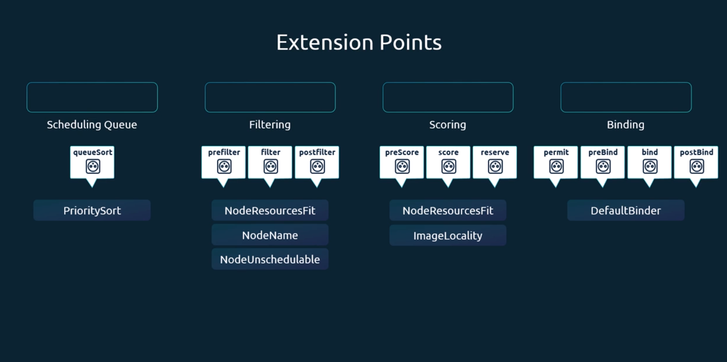
And here is a little bit more details on some additional plugins that come by default that are associated with the different extension points. As you can see, some of the plugins span across multiple extension points, and some of them are just within a specific extension point. So that's what scheduling plugins and extension points are. So, the highly extensible nature of Kubernetes allows us to customize the way that these plugins are called and, and write our own scheduling plugin if needed.
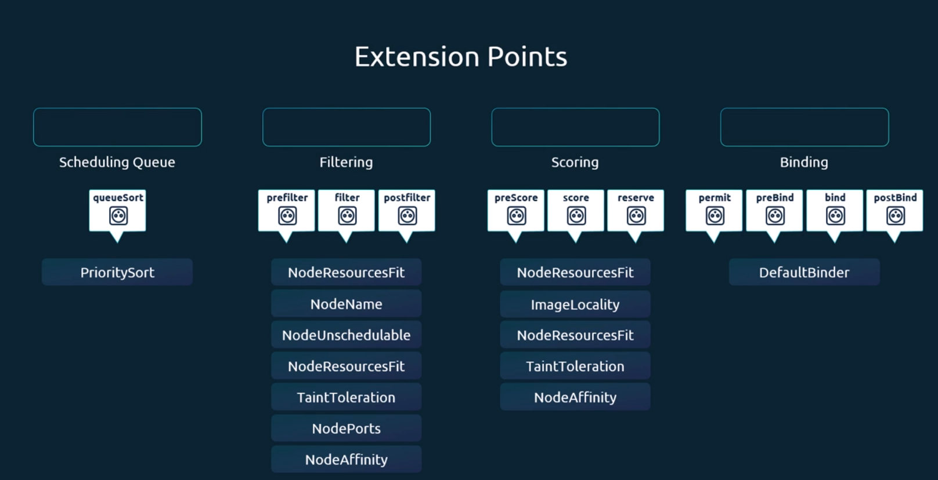
So having learned that, let's look at how we can change the default behavior of how these plugins are called and how we can get our own plugins in there if it's really needed. So, taking a step back earlier, we talked about deploying three separate schedulers, each with a separate scheduler binary. So, we have the default scheduler and then my-scheduler and then my -scheduler-2.
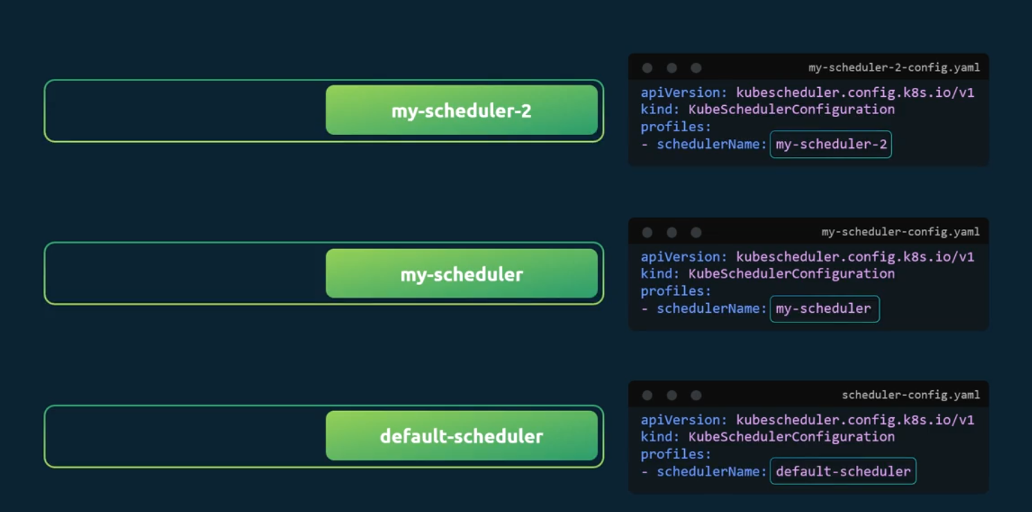
Now all of these are three separate scheduler binaries that are run with a separate scheduler config file associated with each of them. Now that's one way to deploy multiple schedulers. Now the problem here is that since these are separate processes, there is an additional effort required to maintain these separate processes. And also more importantly, since they are separate processes, they may run into race conditions while making scheduling decisions.
For example, one scheduler may schedule a workload on a node without knowing that there's another scheduler scheduling a workload on that same node at the same time.

So, with the 1.18 release of Kubernetes, a feature to support multiple profiles in a single scheduler was introduced. So now you can configure multiple profiles within a single scheduler in the scheduler configuration file by adding more entries to the list of profiles, and for each profile, specify a separate scheduler name.
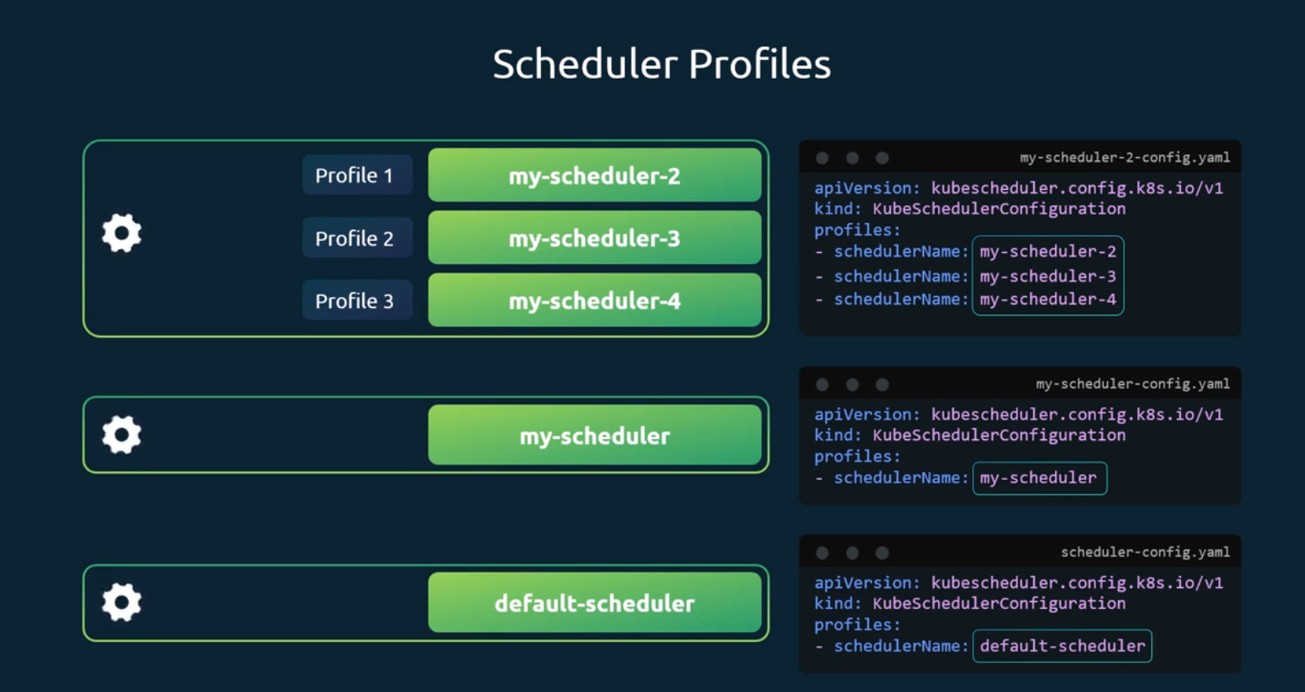
So, this creates a separate profile for each scheduler, which acts as a separate scheduler itself, except that now multiple schedulers are run in the same binary as opposed to creating separate binaries for each scheduler.
Now, how do you configure these different scheduler profiles to work differently? Because right now all of them just simply have different names. So, they're going to work just like the default scheduler. How do you configure them to work differently?
Under each scheduler profile, we can configure the plugins the way we want to. For example, for the scheduler two profile, I'm going to disable certain plugins like the Taint and Toleration plugin and enable my own custom plugins.
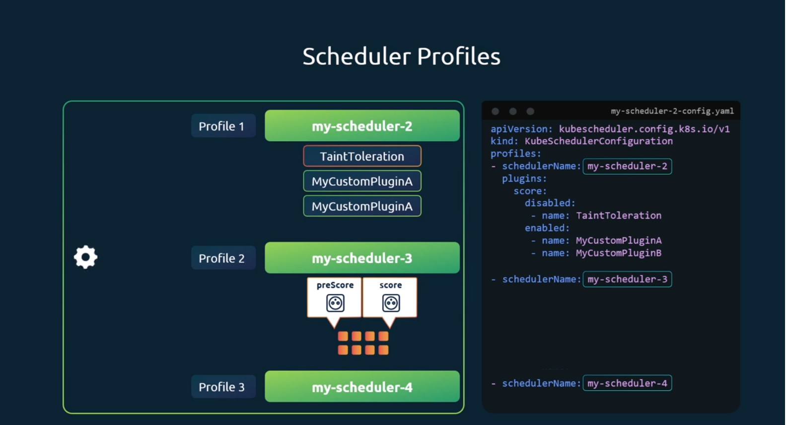
For the scheduler three profile, I'm going to disable all the Pre-score and score plugins, so this is how that's going to look. Under the plugins section, specify the extension point and enable or disable the plugins by name or pattern as shown in this case.
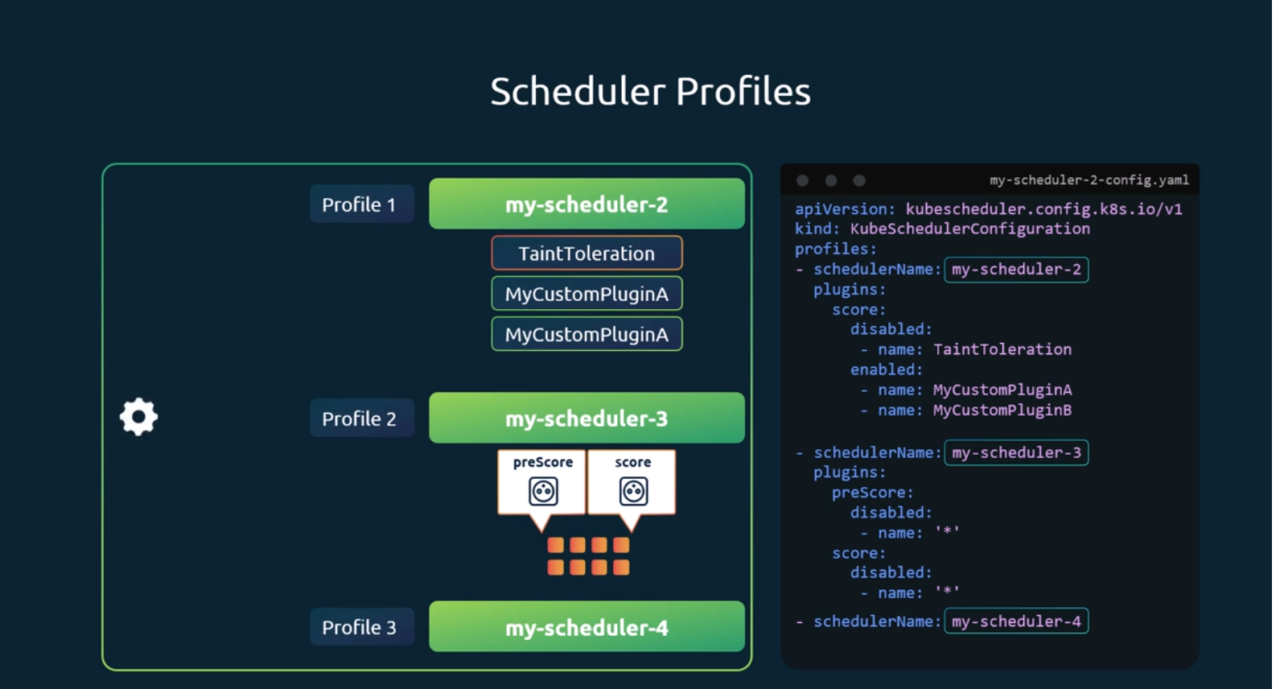

Admission Controllers:
We been running commands from our command line using the kubectl utility to perform various kinds of operations on our Kubernetes cluster. And we know every time we send a request say to create a pod, the request goes to the API server. And then the pod is created and the information is finally persisted in the etcd database.
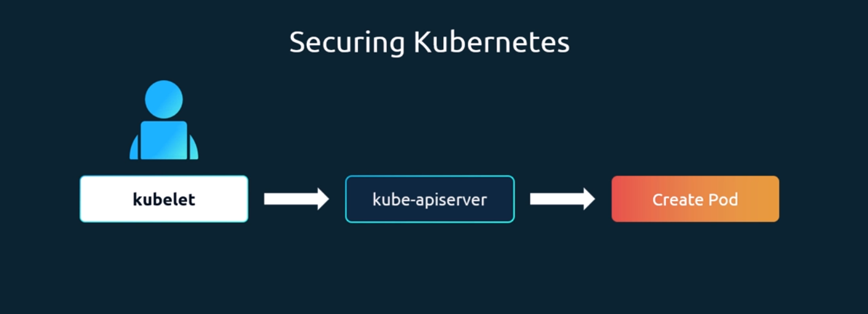
When the request hits the API server, we've learned that it goes through an authentication process, and this is usually done through certificates. If the request was sent through kubectl, we know the kube config file has the certificates configured, and the authentication process is responsible for identifying the user who sent the request and making sure the user is valid.
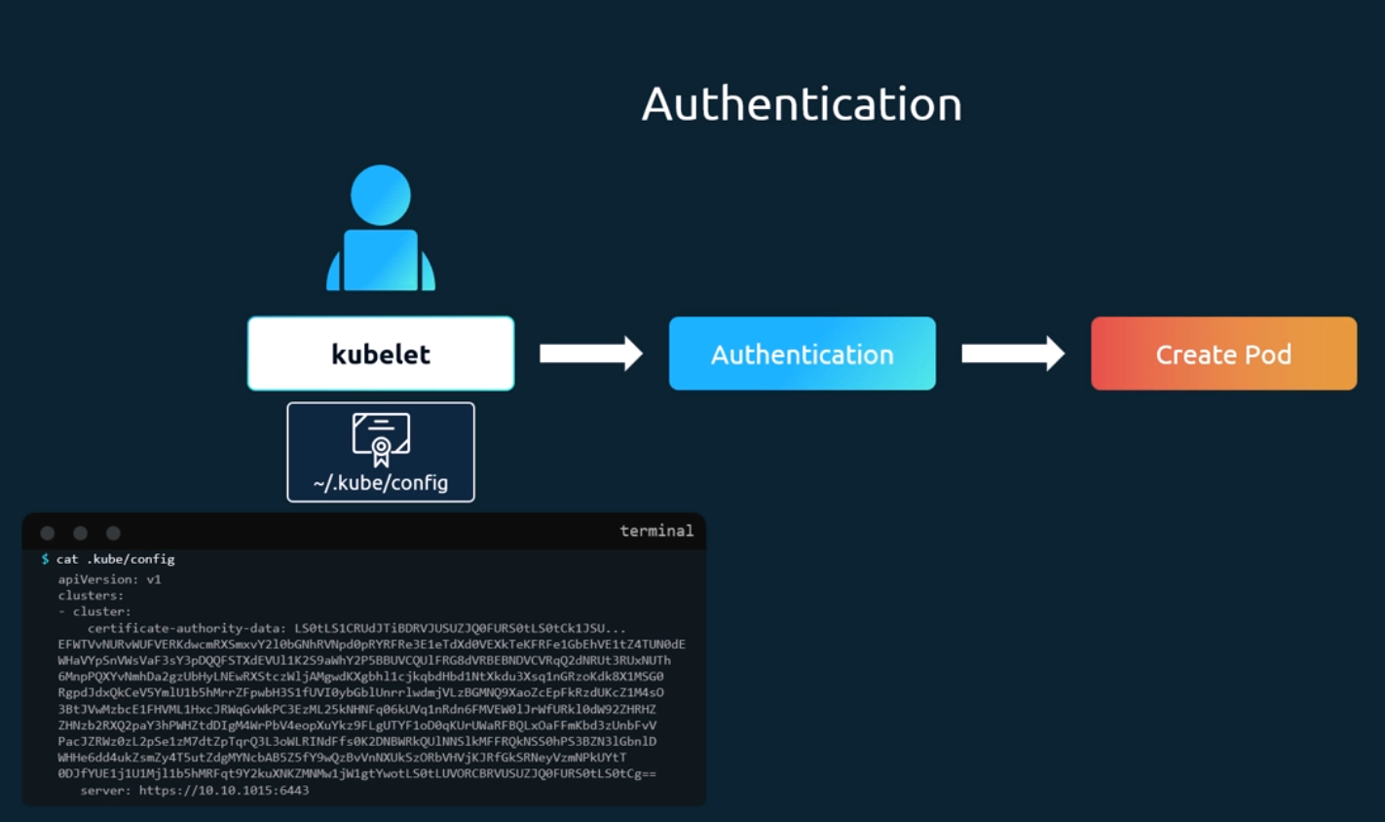
And then the request goes through an authorization process. And this is when we check if the user has permission to perform that operation. And we have learned that this is achieved through role-based access controls.
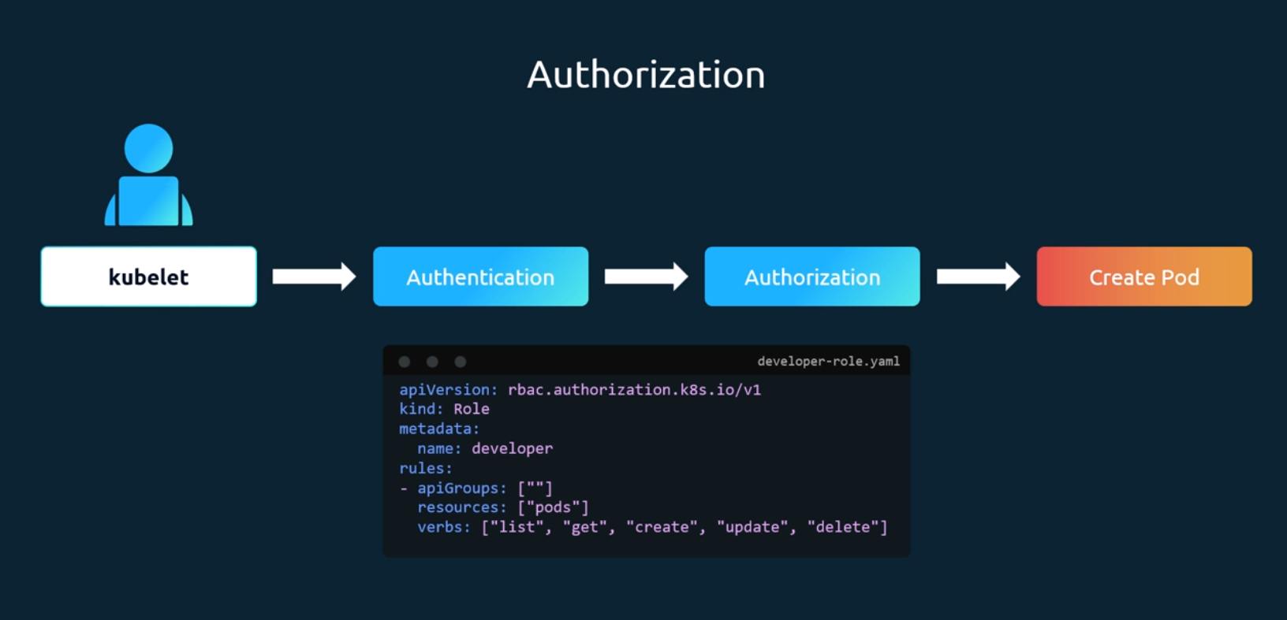
So, in this case, if the user was assigned this particular role of a developer, the user is allowed to list, get, create, update or delete pods. And if the request that came in matched any of these conditions, in this case it does. As the request is to create a pod it is allowed to go through. Otherwise, it's rejected.
So that's authorization with role-based access control.
Now with role-based access control, you could place in different kinds of restrictions, such as to allow or deny those with a particular role to say, create, list or delete different kinds of objects like pods, deployments or services.
We could even restrict access to specific resource names such as, say, a developer can only work on pods named blue or orange, or restrict access within a namespace alone.
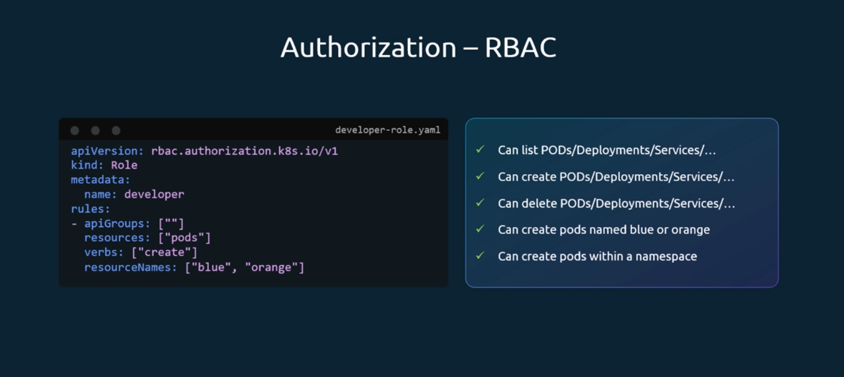
Now, as you can see, most of these rules that you can create with role-based access control is at the Kubernetes API level. And what user is allowed access to what kind of API operations. And it does not go beyond that.
But what if you want to do more than just define what kind of access a user has to an object? For example, when a pod creation request comes in, you'd like to review the configuration file and look at the image name and say that you do not want to allow images from a public Docker Hub registry. Only allow images from a specific internal registry, or to enforce that, we must never use the latest tag for any images. Or say for example, you'd like to say if the container is running as the root user. Then you do not want to allow that request or allow certain capabilities only, or to enforce that the metadata always contains labels.
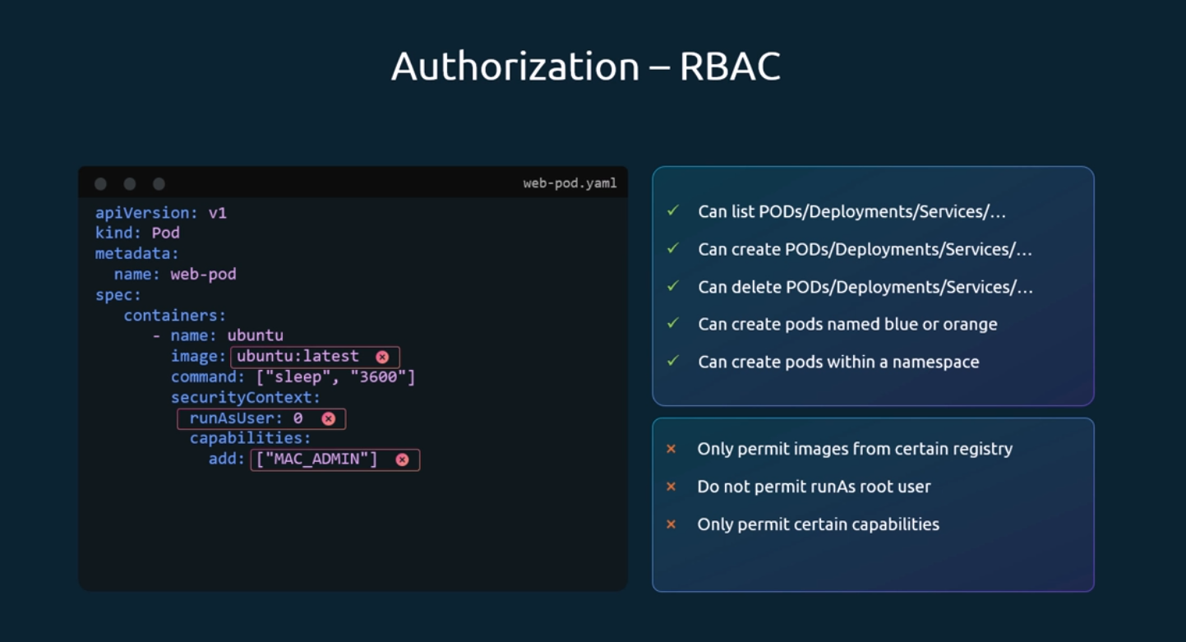
So, these are some of the things that you can't achieve with the existing role-based access controls.
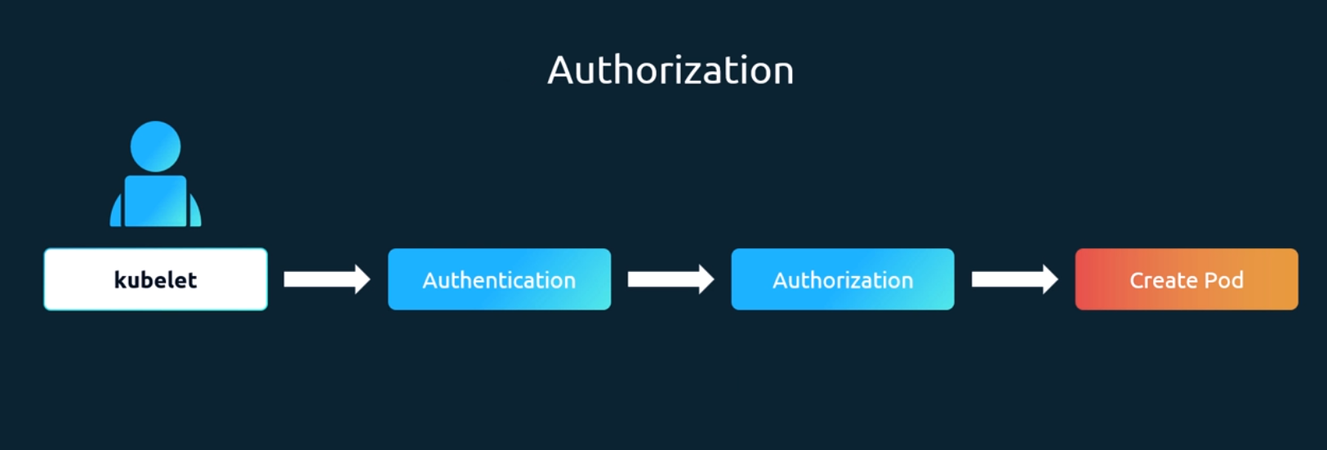
And that is where admission controllers come in.
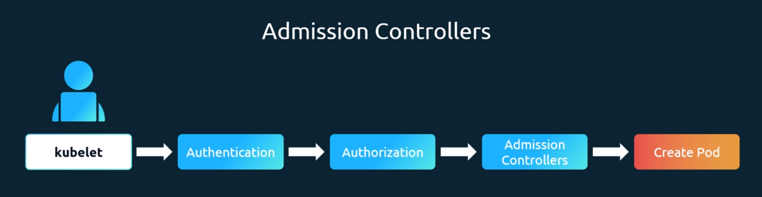
Admission controllers help us implement better security measures to enforce how a cluster is used. Apart from simply validating configuration, admission controllers can do a lot more, such as change the request itself or perform additional operations before the pod gets created. We will go over some examples in the upcoming slides.
There are a number of admission controllers that come pre-built with Kubernetes, such as always pull images that ensures that every time a pod is created, the images are always pulled. The default storage class admission controller that observes the creation of PVCs and automatically adds the default storage class to them if one is not specified, the event rate limit admission controller can help set a limit on the requests with the API server can handle at a time to prevent the API server from flooding with requests, the namespace exists. Admission controller rejects requests to namespaces that do not exist, and there are many more admission controllers available.
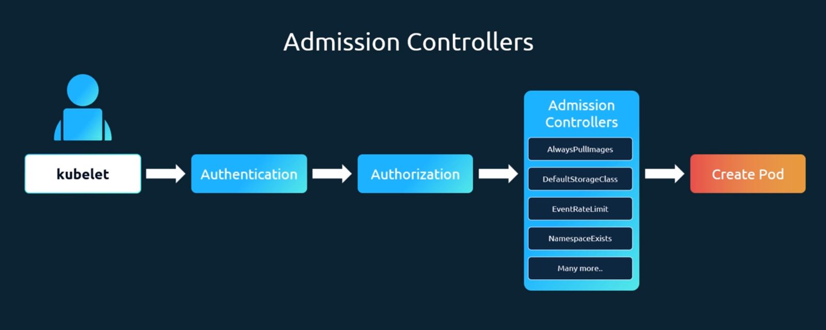
So, let's take that as an example and look at it in a bit more detail. The namespace exists admission controller.
Say we want to create a pod in a namespace called blue that doesn't exist. If I run this command, it would throw an error that says the namespace blue is not found.
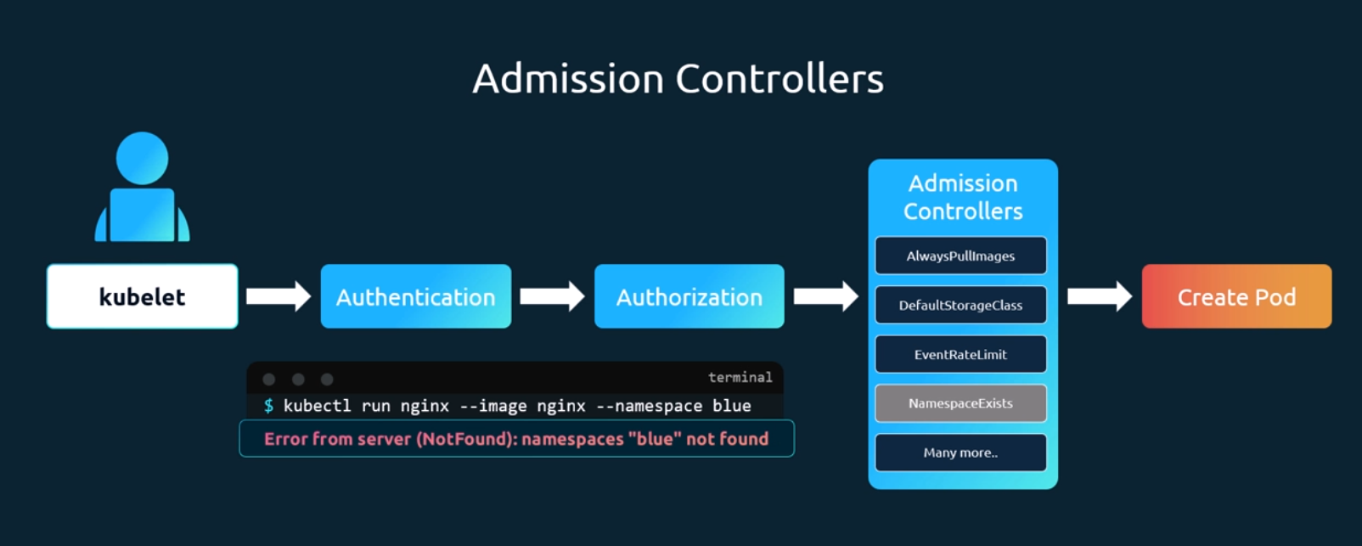
What's happening here is that my request gets authenticated, then authorized, and it then goes through the admission controllers, The namespace exists.
That mission controller handles the request and checks if the namespace is available. If it is not, the request is rejected, the namespace exists, is a built-in admission controller that is enabled by default.
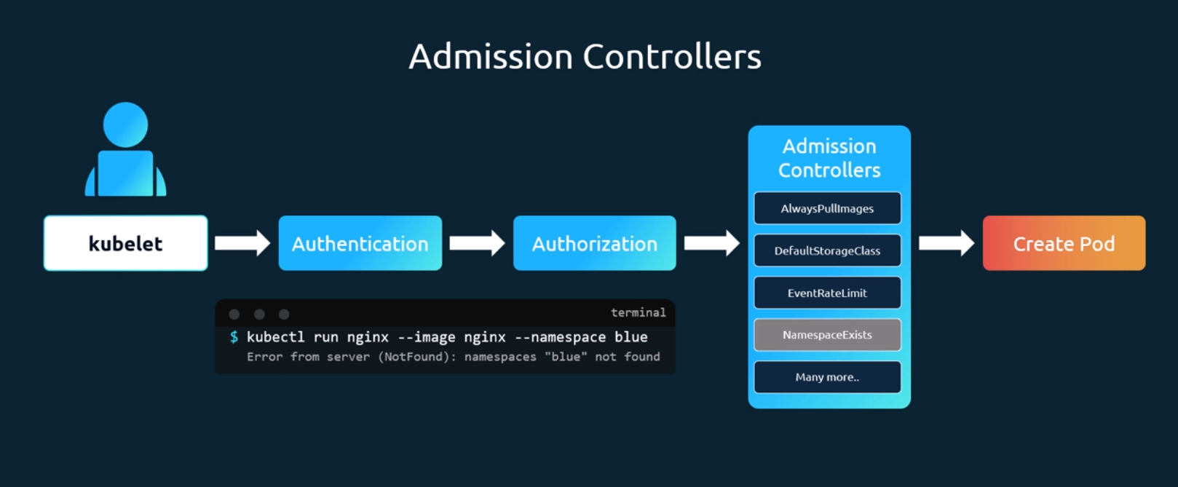
There is another admission controller that is not enabled by default, and that is called as the namespace auto provision admission controller.
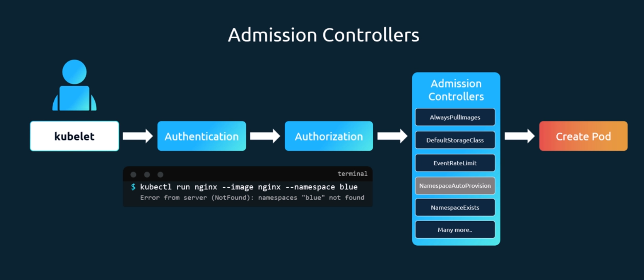
This will automatically create the namespace if it does not exist.
We will see how it can be enabled in a minute. First, to see a list of admission controllers enabled by default, run the kube API server command and grep for enable admission plugins. Now here you will see a list of admission controllers that are enabled by default.
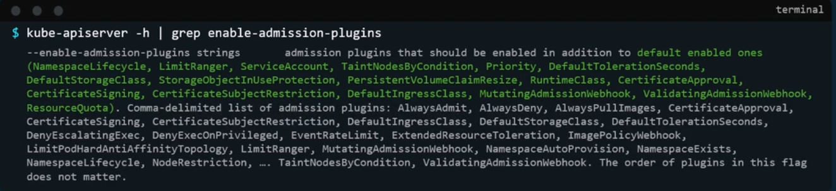
The ones that are highlighted in green. Note that if you're running this in a kube ADM based setup, then you must run this command within the kube API. Server control plane pod using the kubectl exec command first, like this.
To add an admission controller, update the enable admission plugins flag on the kube API server service to add the new admission controller.
So, if you're in a kube ADM based setup, then update the flag within the kube API server manifest file as shown here on the right.
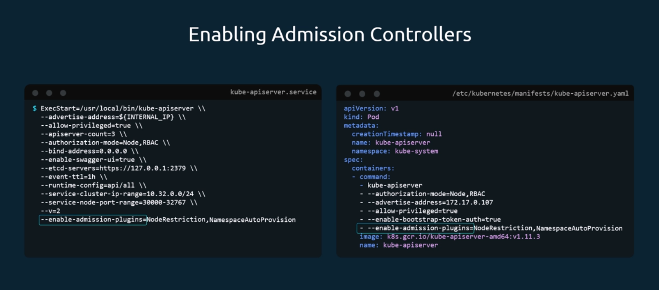
So, the one on the left is if you're updating the kube API server service, and the one on the right is if the API server is running as a pod in a kube based setup.
Similarly, to disable admission controller plugins, you could use the disable admission plugins flag.
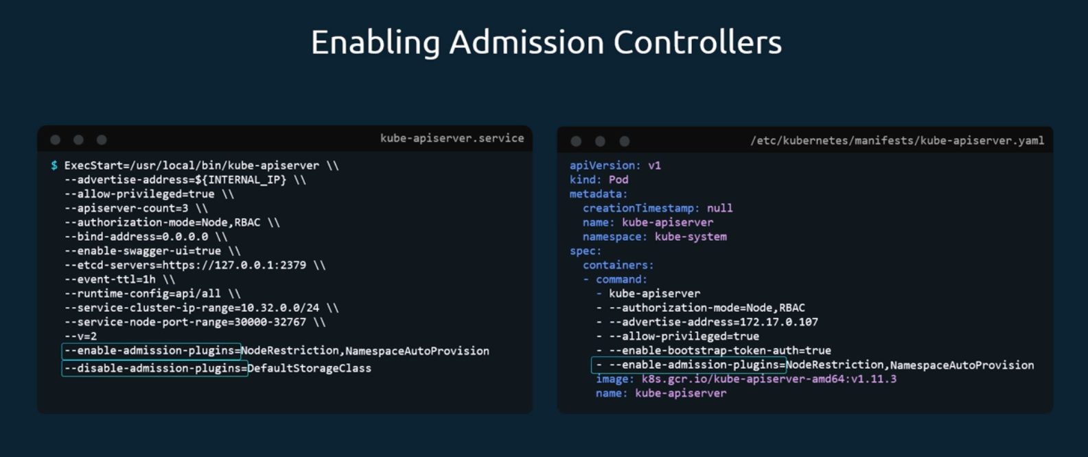
Once updated, the next time we run the command to provision a pod in a namespace that does not exist yet, the request goes through authentication, then authorization, and then the namespace auto provision controller, at which point it realizes that the namespace doesn't exist, so it creates namespace automatically and the request goes through successfully to create the pod. If you list the namespaces now, you'll see that the namespace is automatically created.
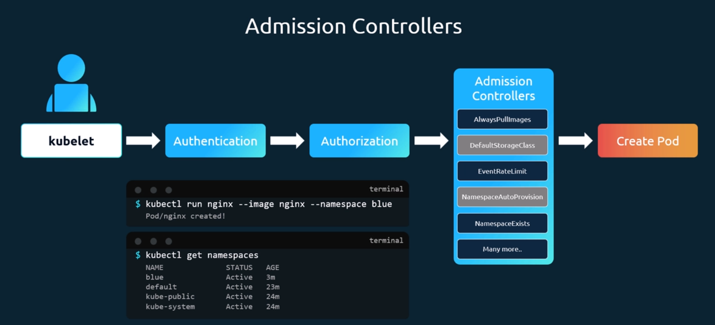
So that's one example of how an admission controller works.
It can not only validate and reject requests from users, it can also perform operations in the backend or change the request itself.
Note that the namespace, auto provision, and namespace exist. Admission controllers are deprecated and is now replaced by the namespace lifecycle admission controller. The namespace lifecycle admission controller will make sure that requests to a non-existent namespace is rejected, and that the default namespaces such as default kube system and kube public cannot be deleted.

Lab Solution Admission Controllers:
what is not a function of admission controllers? authenticate users.
which admission controller is not enabled by default? the way we can get this information is by checking the enable-admission-plugins in the Kube-apiserver help options.
$ kubectl get pods -n kube-system
You'll see that we have the kube-apiserver-controlplane.
$ kubectl exec -it kube-apiserver-controlplane -n kube-system -- kube-apiserver -h | grep ‘enable-admission-plugins’
which admission controller is enabled in this cluster which is normally disabled?
we have to go to the kube-apiserver.yaml.config, so this is going to be in /etc/kubernetes/manifests/kube-apiserver.yaml, searching for enable-admission-plugin or grep enable-admission-plugins /etc/kubernetes/manifests/kube-apiserver.yaml.
-------
if you wanted it to automatically create a namespace for you, you could enable the NamespaceAutoProvision admission controller. we want to go back into that same file, the /etc/kubernetes/manifests/kube-apiserver. we want to go down to the same line we looked at, at one of the previous questions, which is the enable-admission-plugins, and we can see we just have NodeRestriction, so we're just gonna add the new one after this. we'll just add a comma, and then put in the name of the new admission controller that you want enabled, so that's gonna be NamespaceAutoProvision.

the NamespaceExists and the NamespaceAutoProvision admission controllers are deprecated and are now replaced by the NamespaceLifecycle admission controller.

disable the DefaultStorageClass admission controller. vi /etc/kubernetes/manifests/ kube-apiserver. And just like we had the enable-admission-plugin, we're going to add a disable-admission-plugin.
- --disable-admission-plugins=DefaultStorageClass.

Validating and Mutating Admission Controllers:
We looked at the namespace exists or namespace lifecycle admission controller. It can help validate if a namespace already exists and reject the request if it doesn't exist. This is known as a validating admission controller.
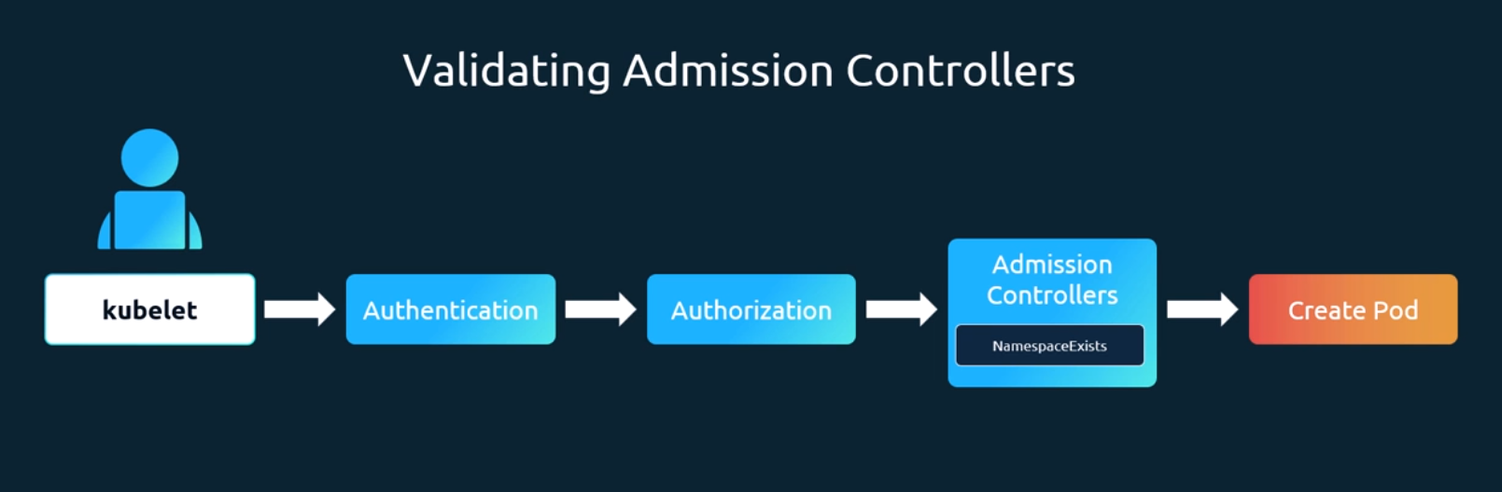
Let's look at another type of admission controller plugin named as the default storage class plugin. This is a plugin that is enabled by default. Say for example, you're submitting a request to create a PVC.
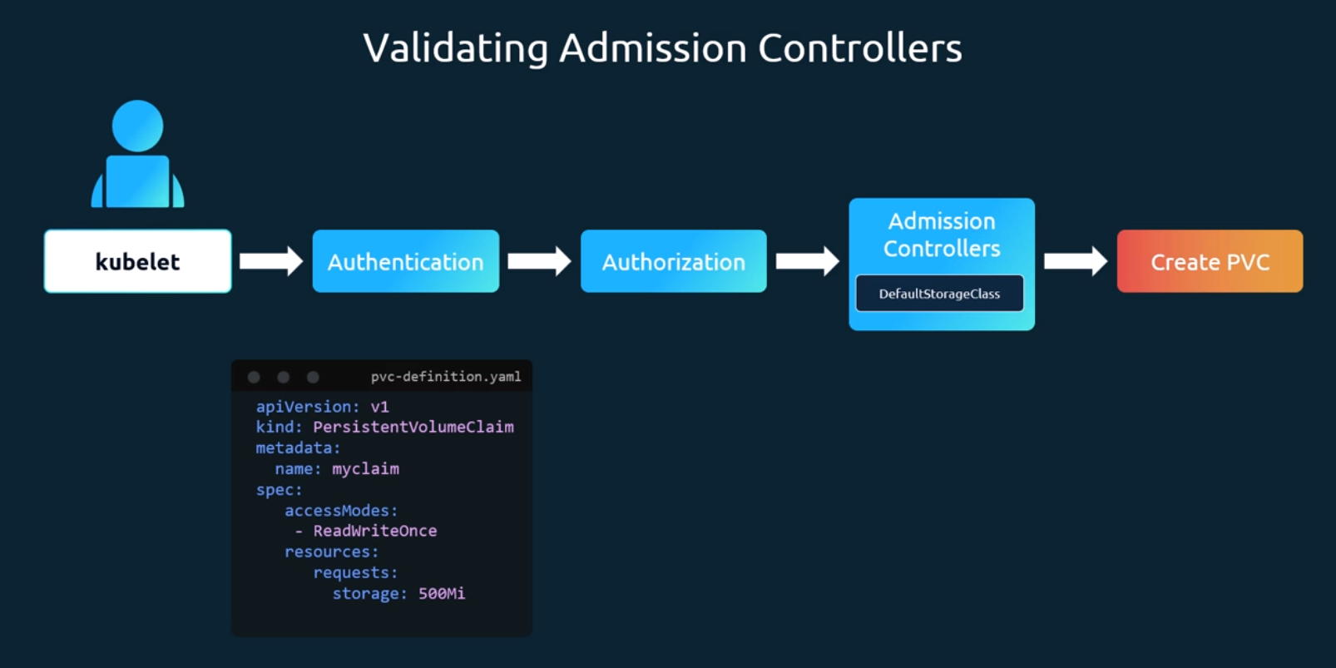
The request goes through authentication, authorization, and finally the admission controller. The default storage class admission controller will watch for requests to create a PVC and check if it has a storage class mentioned in it.
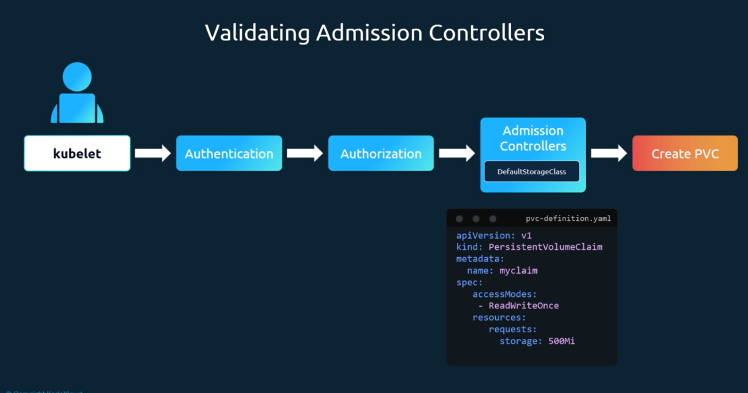
If not, which is true in our case, it will modify your request to add the default storage class to your request.
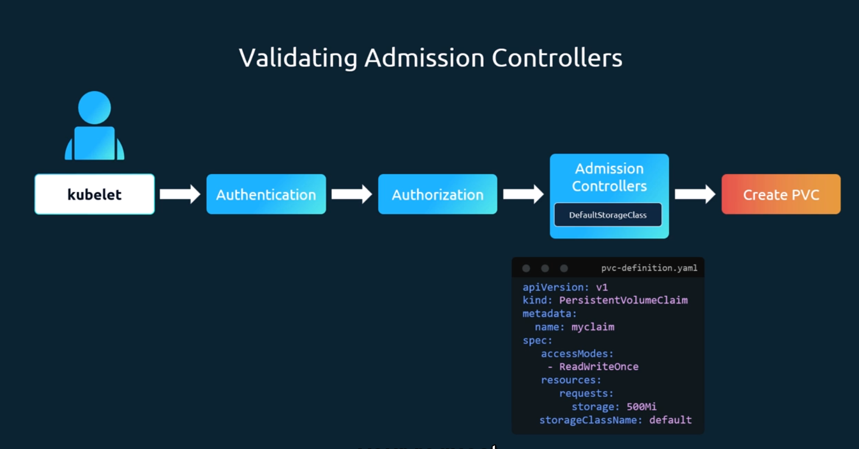
This could be whatever storage class is configured as the default storage class in your cluster. So, when the PVC is created and you inspect it, you will see that a storage class default is added to it even though you hadn't specified it during the creation.
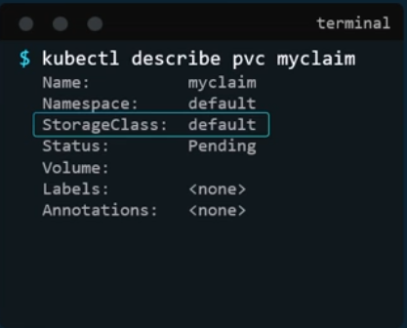
So, this type of admission controller is known as a mutating admission controller. It can change or mutate the object itself before it is created.
So those are two types of admission controllers. Mutating admission controllers are those that can change the request, and validating admission controllers are those that can validate the request and allow or deny it.
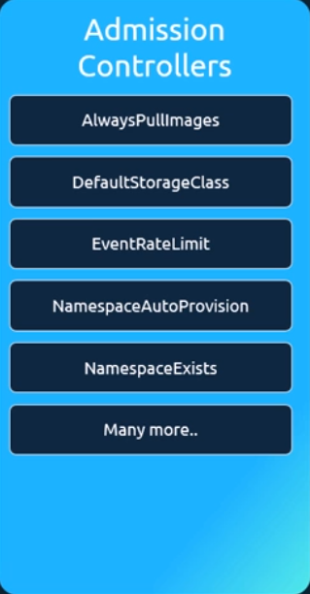
And there may be admission controllers that can do both that can mutate a request as well as validate a request.
Now, generally mutating admission controllers are invoked first, followed by validating admission controllers. This is so that any change made by the mutating admission controller can be considered during the validation process. In this example, the namespace auto provisioning admission controller, which is a mutating admission controller, is run first, followed by the validating controller namespace exists. If it was run the other way, then the namespace exists. Admission controller would always reject the request for namespace that does not exist, and the namespace auto provisioning controller would never be invoked to create the namespace.
And when a request goes through these admission controllers, if any admission controller rejects the request, the request is rejected and an error message is shown to the user.
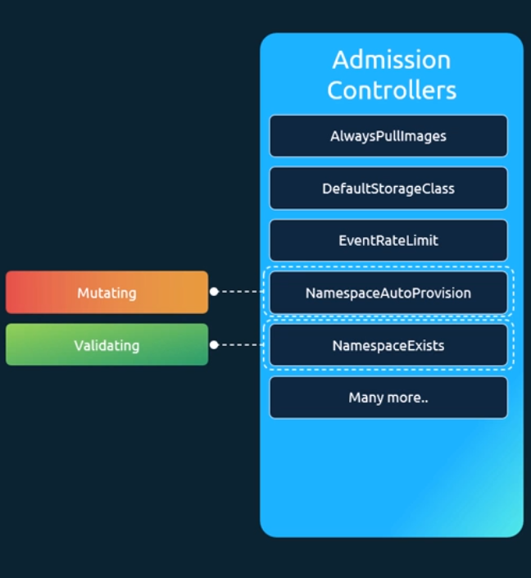
Now, these are all built in admission controllers that are part of the Kubernetes source code and are compiled and shipped with Kubernetes. Now, what if we want our own admission controller with our own mutations and validations, that has our own logic?
You support external admission controllers. There are two special admission controllers available mutating Admission Webhook and then Validating admission Webhook.
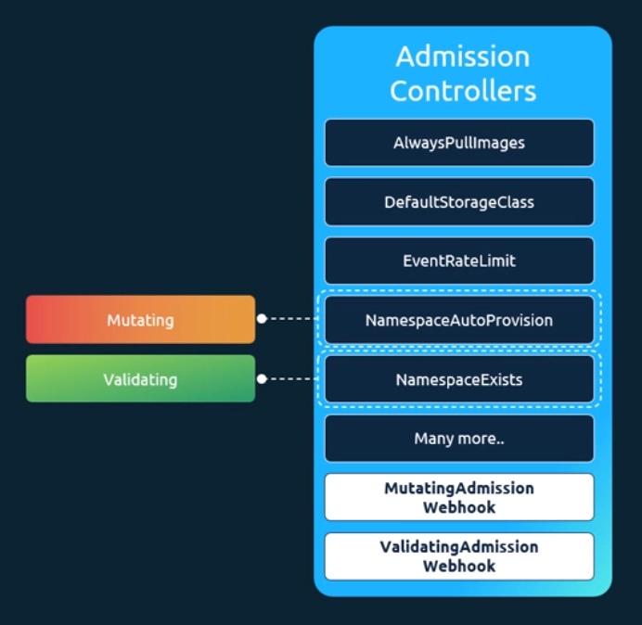

We can configure these webhooks to point to a server that's hosted either within the Kubernetes cluster or outside it. And our server will have our own admission webhook service running with our own code and logic. After a request goes through all the built in admission controllers, it hits the webhook that's configured. We will see how to configure that in a bit. And then and then once it hits the webhook, it makes a call to the admission webhook server by passing in an admission review object in a JSON format. This object has all the details about the request, such as the user that made the request and the type of operation the user is trying to perform, and on what objects and the and details about the object itself. On receiving the request, the admission webhook server responds with an admission review object with a result of whether the request is allowed or not. If the allowed field in the response is set to true, then the request is allowed and if it's set to false, it is rejected.
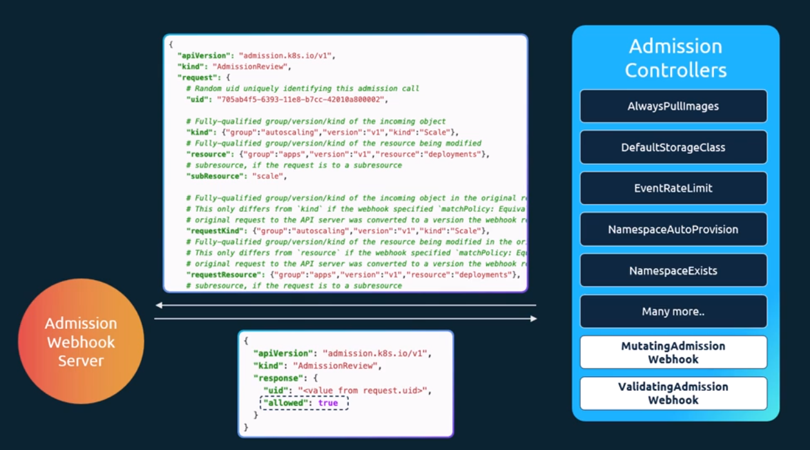
So how do we set this up? First, we must deploy our admission webhook server, which will have our own logic, and then we configure the webhook on Kubernetes by creating a webhook configuration object.
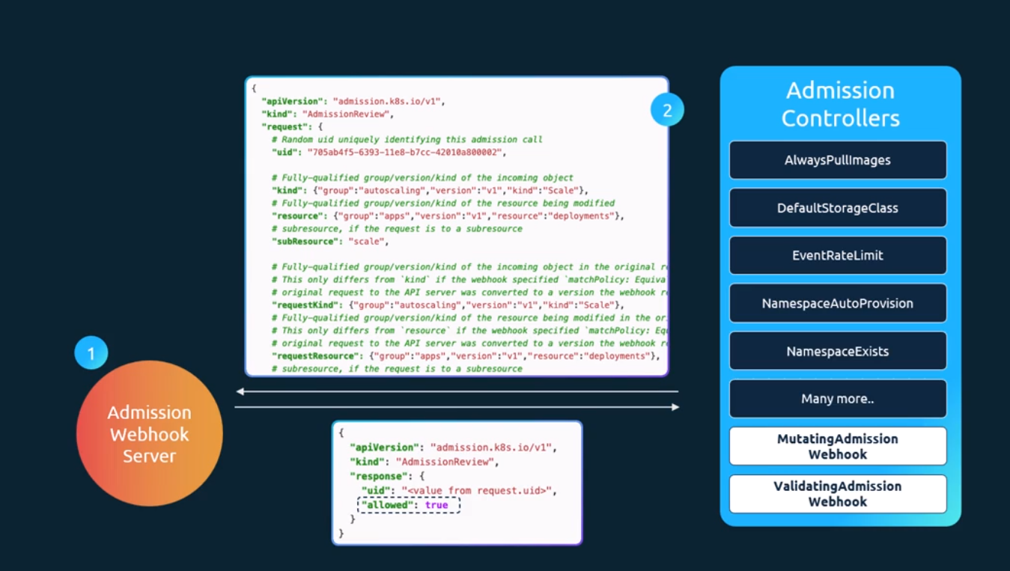
So, let's take a look at each of these steps next. So, the first step is to deploy our own webhook server. Now this could be an API server that could be built on any platform. An example code of a webhook server written in go can be found here in the Kubernetes documentation pages. It's written in the go programming language. You could develop your own server in other languages as well if required. The only requirement is that it must accept the mutate and validate APIs and respond with a JSON object that the web server expects.
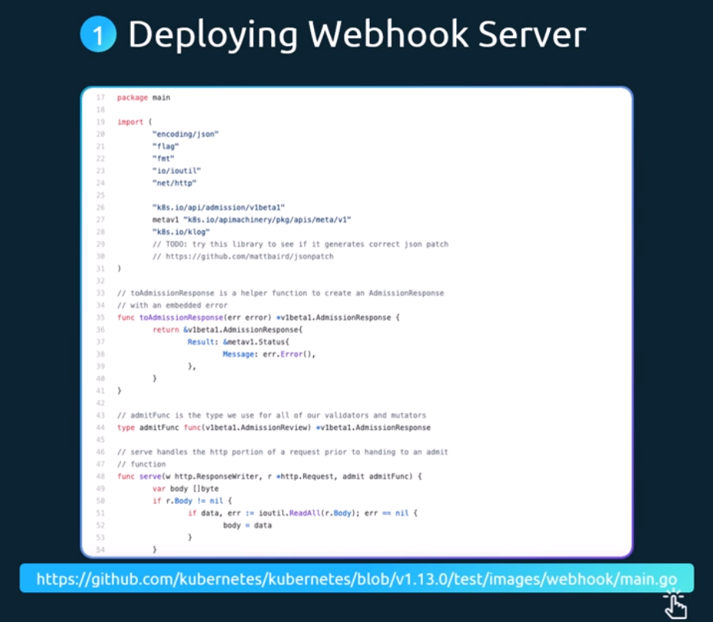
So, here's a pseudo code of a simple webhook server written in Python. There are two calls a validate call and a mutate call. The validate call receives the validation webhook request, and in this example compares the name of the object and the name of the user who sent the request and rejects the request if it's the same name. Well, just a simple sample use case to show what we can do with the requests that come in. And if you look down, we'll see the mutating webhook which gets the username and responds with a JSON patch operation of adding the username as a label to any request that was raised by anyone. So, if you take a closer look at this particular piece of code, a patch object is a list of patch operations, with each operation being add, remove, replace, move, copy, or test. And we then specify the path within the JSON object that needs to be targeted for change. In this case, it is slash metadata slash label slash users. And then the value that needs to be added if it is an add operation. So, we get the username from the request. So that's going to be the value of that particular label. This is then sent as a base64 encoded object as part of the response.
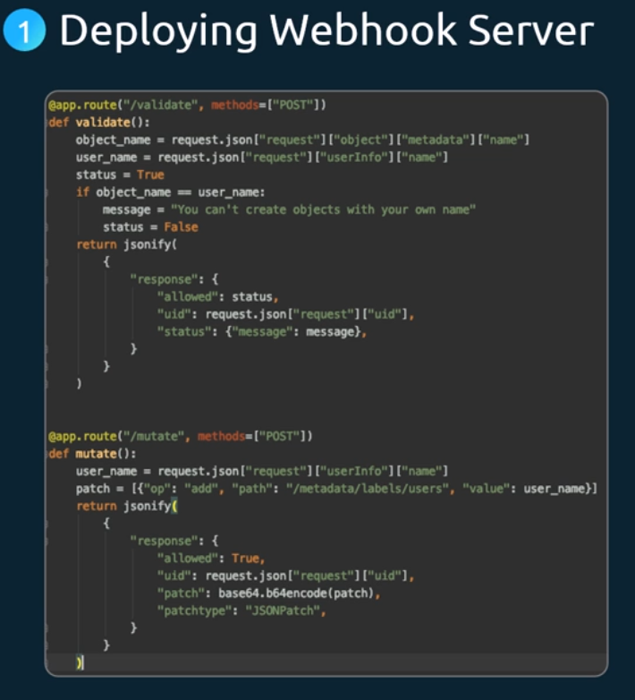
Once we have developed our own webhook server, the next step is to host it. So, we either run it as a server somewhere or containerize it and deploy it within Kubernetes cluster itself as a deployment. If deployed as a deployment in a Kubernetes cluster, then it needs a service for it to be accessed. So, we have a service named Webhook Service as well.
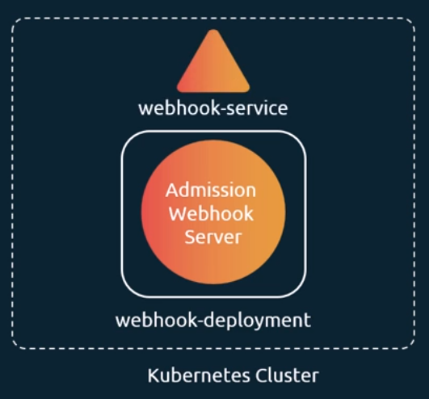
The next step is to configure our cluster to reach out to the service and validate or mutate the requests. For this, we create a validating webhook configuration object. So, we start with the API version kind metadata and webhooks section. API version is admission registration.io v1. Kind is validating webhook configuration. If we are configuring a mutating webhook this would be a mutating webhook configuration. We then give it a name. Now under webhooks we configure the different webhooks. So, a webhook has a name, a client config and a set of rules. So, the name we set it to example.com. The client config is where we configure the location of our admission webhook server. If we deploy this server externally on our own, and that is not a part of a deployment in Kubernetes cluster, then we can simply provide a URL path to that server like this:
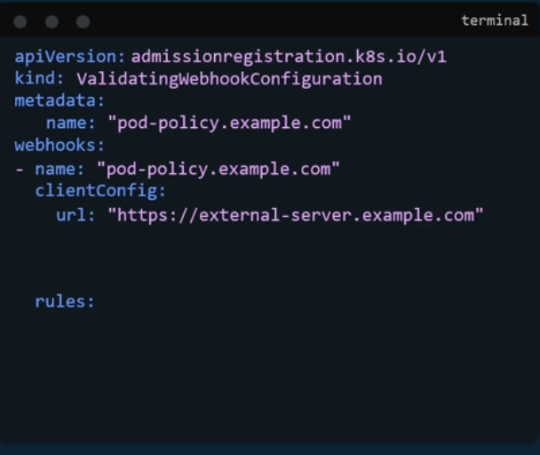
Now instead, if we deployed the server as another service on our own cluster, as we see here as it is on the left, then we can use the service configuration and provide the namespace and name of the service, which in our case is webhook dash service.
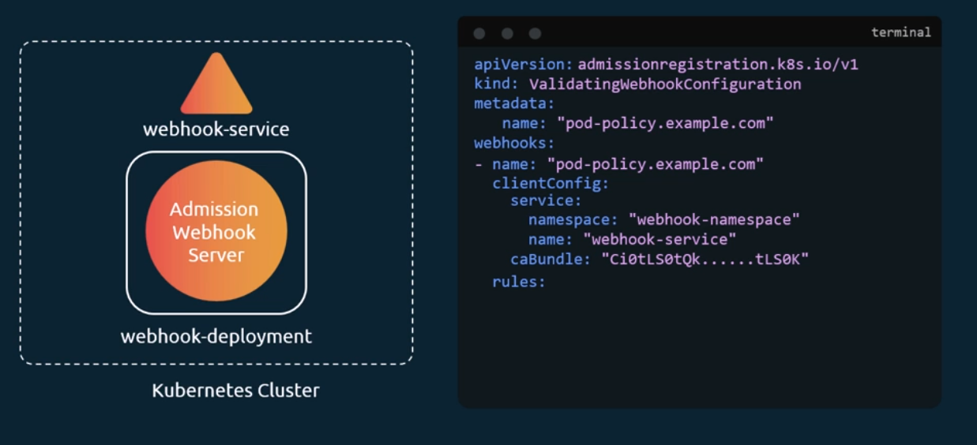
Now of course, the communication between the API server and the webhook server has to be over TLS. So, a certificate bundle should be configured. So, the server has to be configured with a pair of certificates. Then a Certificate. ACA bundle is to be created and passed into this client config SCA bundle. Next, we must specify when to call our API server. We can specify rules to configure exactly when we want our webhook server to be called for validation. Now we might not want to do that for all of the calls. For example, we may only want it to be called while creating pods, or deleting pods, or creating deployments, etc. whatever that may be. It can be added as a rule under the rules section using API groups, API versions, operation types and resources.
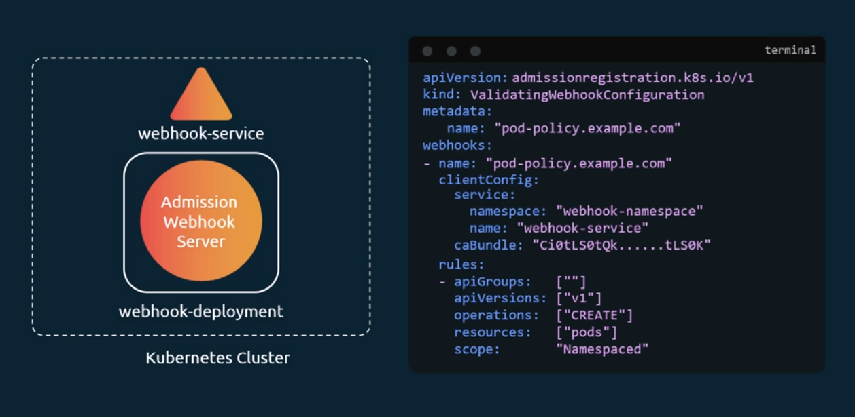
In this example, we're only going to call this webhook configuration when calls are made to create pods, and that should be it. Once this object is created, every time we create a pod, a call would be made to the webhook service and depending on the response, it would be allowed or rejected.

Create TLS secret:
$kubectl -n webhook-demo create secret tls webhook-server-tls –cert “/root/keys/ webhook-server-tls.cert” –key “webhook-server-tls.key”

